Supplemental Digital Content

Supplemental Digital Content, table 1.
Aetiologies of AMS in the ED stratified against age (n = 554)
Etiologic factors | No. of patients (%) | Patients <60 years (n=189) | Patients $≥$60 years (n=365) | P value
Neurological causes
Cerebrovascular disease | 24 (4.33) | 7 (3.70) | 17 (4.66) | 0.601
Seizures/epilepsy | 19 (3.43) | 6 (3.17) | 13 (3.56) | 0.812
Traumatic brain injury | 16 (2.89) | 6 (3.17) | 10 (2.74) | 0.772
Dementia or delirium | 14 (2.53) | 2 (1.09) | 12 (3.29) | 0.155
Other diseases of CNS | 13 (2.35) | 3 (1.53) | 10 (2.74) | 0.558
Non-neurological causes¹
Infections | 105 (18.95) | 7 (3.70) | 98 (26.85) | $≤$0.001***
Pneumonia | 45 (8.12) | 3 (1.59) | 42 (11.51) | $≤$0.001***
Urinary tract | 33 (5.96) | 1 (0.53) | 32 (8.77) | $≤$0.001***
Sepsis | 8 (1.44) | 1 (0.53) | 7 (1.92) | 0.194
Other | 19 (3.43) | 2 (1.06) | 17 (4.66) | <0.05*
Intoxication | 74 (13.36) | 56 (29.63) | 18 (4.93) | $≤$0.001***
Acute alcohol intoxication | 48 (8.66) | 40 (21.16) | 8 (2.19) | $≤$0.001***
Intoxication, non-alcoholic | 26 (4.69) | 16 (8.47) | 10 (2.74) | $≤$0.01**
System/organ dysfunction | 47 (8.48) | 10 (5.29) | 37 (10.14) | 0.052
Metabolic, nutritional, or endocrinal | 30 (5.42) | 6 (3.17) | 24 (3.56) | 0.094
Trauma | 26 (4.69) | 12 (6.35) | 14 (3.83) | 0.185
Miscellaneous² | 23 (4.15) | 6 (3.17) | 17 (4.66) | 0.407
R-diagnoses³ | 123 (22.20) | 53 (28.04) | 70 (19.18) | $≤$0.05*
Fainting/syncope | 39 (7.04) | 16 (8.47) | 23 (6.30) | 0.345
Convulsions/cramps | 16 (2.89) | 8 (4.23) | 8 (2.19) | 0.174
Malaise | 15 (2.71) | 9 (4.76) | 6 (1.64) | $≤$0.05*
Other R-diagnoses | 53 (9.57) | 20 (10.58) | 33 (9.04) | 0.559
Z-diagnoses⁴ | 40 (7.22) | 15 (7.94) | 25 (6.85) | 0.639
Note: ¹Oncologic and infectious diseases involving CNS were included in ‘other diseases of CNS’ (n = 4). ² Miscellaneous diagnosis includes different extra-cranial diagnoses within ICD10 chapters 1-14, e.g., oncologic diseases (n = 7) and psychiatric diseases (n = 4). Grey lettering indicates subdivision of the aetiological factor. *p < 0.05, **p ≤ 0.01, ***p ≤ 0.001.

Supplemental Digital Content, fig. 1.

Age distribution. Frequency of specific age occurrence in the study population.
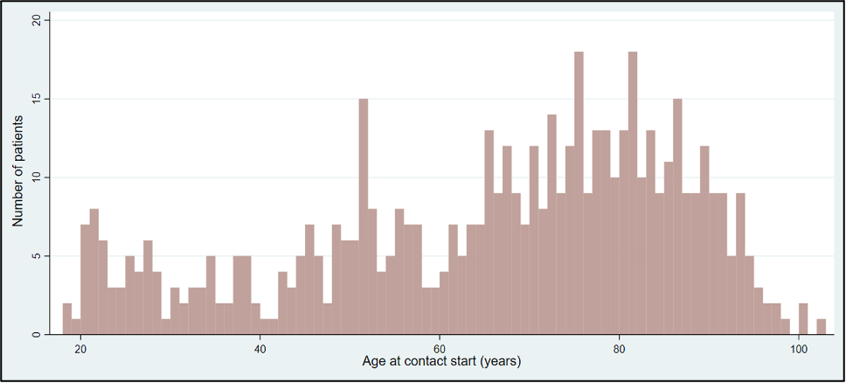

Supplemental Digital Content, fig. 2.
Kaplan-Meier Curve. Cumulative incidence proportions for the five aetiologies with the most observed deaths.

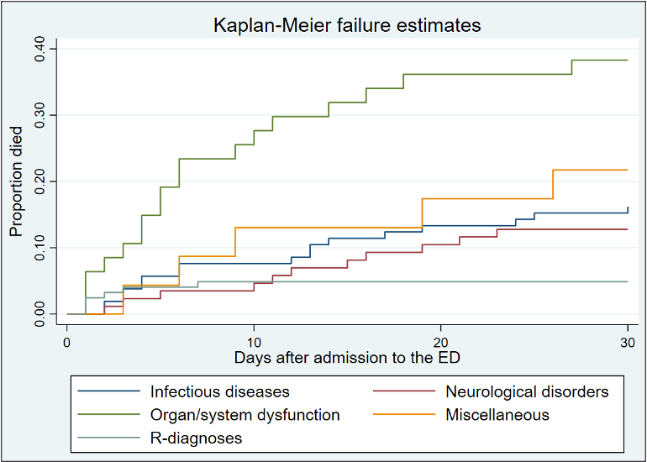

Day one indicates the day of admission to the ED. Log-rank test p < 0.001***.

