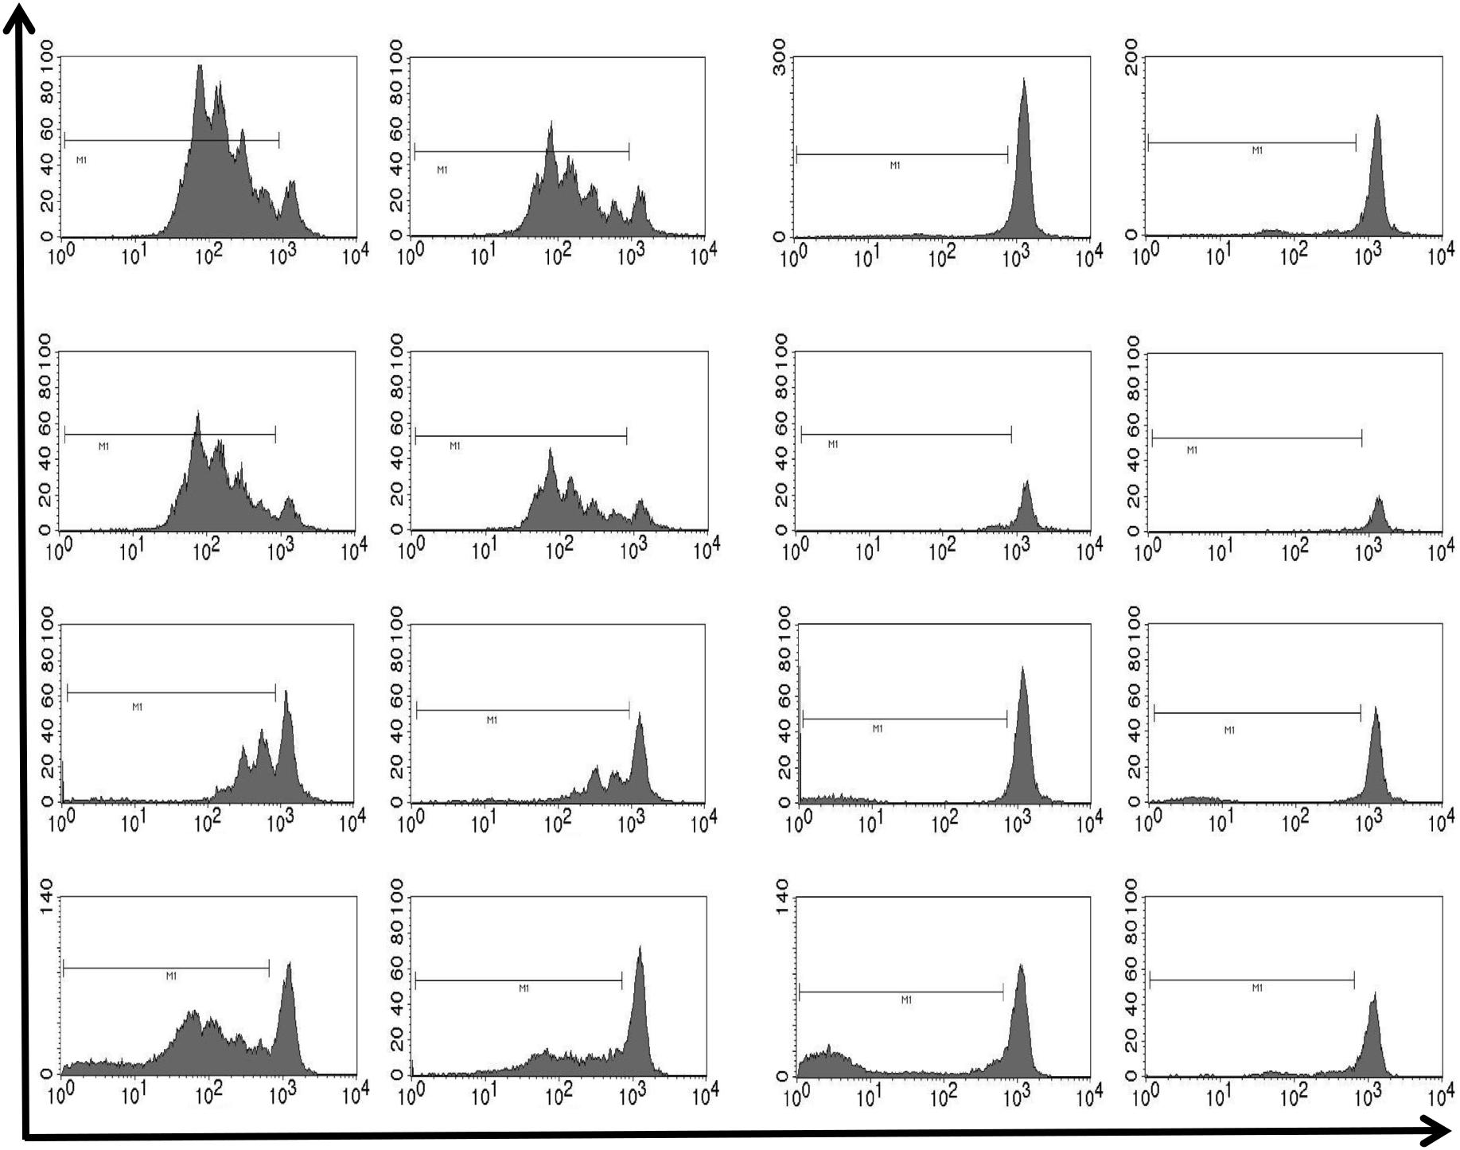

Figure S1: Representative histograms of polyclonal T cell proliferation assay. Responder PBMCs were isolated, labelled with CFSE and stimulated with OKT3 and IL-2 to induce polyclonal T cell proliferation. The stimulated responder PBMCs were co-cultured with allogenic MSCs, MDSCs, or CD4⁺CD25⁺
Tregs in different ratios for 4-5 days at 37°C and 5 % CO₂. Stimulated PBMCs without immunomodulatory cells and unstimulated PBMCs were seeded as controls. After incubation, proliferation of CD4⁺ and CD8⁺ T cells was analyzed by flow cytometry. Representative histograms in the ratios 1:0.16 and 1:0.5 are shown.

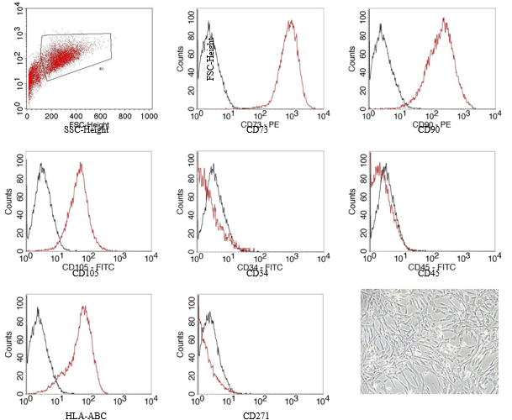
Figure S2: Characterization of MSCs. Human MSCs were isolated, cultured and cell morphology was analyzed at ×20 original magnification by Zeiss Axiovert 135 microscopy (Carl Zeiss) using Canon EOS 550D camera (Canon) and Eos Utility software (Canon). The immunophenotype of MSCs was confirmed as CD73⁺, CD90⁺, CD105⁺, HLA-ABC⁺, CD34⁻, CD45⁻, and CD27⁻. Representative histograms are shown with surface markers in red and isotype controls in black.

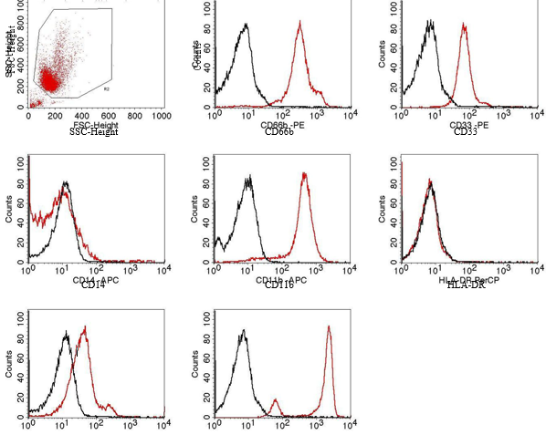
Figure S3: Characterization of PMN-MDSCs. PMN-MDSCs were obtained from PBMC fraction by magnetic separation with anti-human CD66b-FITC antibodies and anti-FITC MicroBeads. The immunophenotype of PMN-MDSCs was determined as SSC^{high}, CD66b⁺, CD33⁺, CD11b⁺, CXCR4⁺, CD16⁺, CD14⁻, and HLA-DR⁻. Shown are representative histograms with surface markers in red and isotype controls in black.
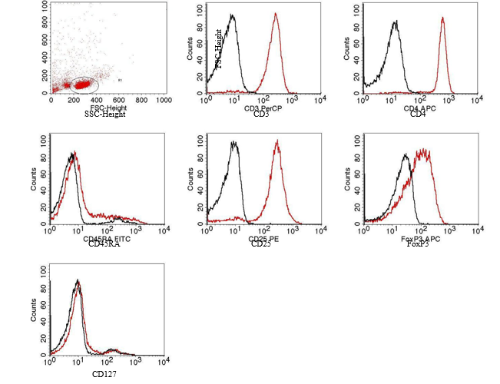

Figure S4: Characterization of regulatory CD4⁺CD25⁺ T cells. Tregs were isolated from the PBMC fraction by using CD4⁺CD25⁺ Regulatory T Cell Isolation Kit (Miltenyi Biotec). Tregs were identified as CD3⁺, CD4⁺, CD25⁺, FoxP3⁺, CD127⁻, and CD45RA^{low}. Typical histograms are presented with cell markers in red and isotype controls in black.
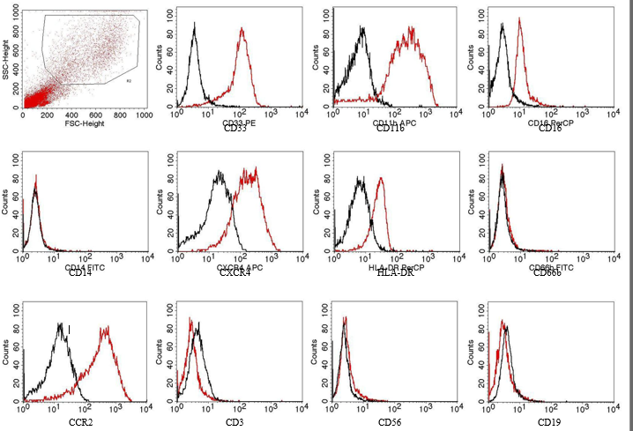
Figure S5: Characterization of PBMC-derived cytokine-induced MDSCs. PBMCs were cultured in complete medium for 7 days with 10 ng/ml GM-CSF. Cytokine-induced MDSCs from PBMCs were identified as SSC^{high}, CD33⁺, CD11b⁺ and CD14⁻ as well as CXCR4⁺, CD16⁺, CD66b⁻, HLA-DR^{inter}, CCR2⁺, and negative lineage markers (CD3, CD19, CD56). In the representative histograms, surface markers are shown in red and isotype controls in black.

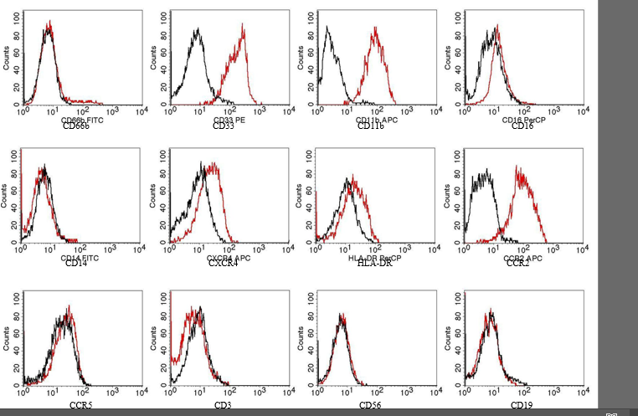
Figure S6: Characterization of BMMC-derived cytokine-induced MDSCs. After density gradient centrifugation of bone marrow aspirates, BMMCs were cultured in complete medium for 7 days with 10 ng/ml GM-CSF. Cytokine-induced MDSCs from BMMCs were determined as SSC^{high}, CD33⁺, CD11b⁺ and CD14⁻, additional confirmed as CXCR4⁺, CD16⁺, CD66b⁻, HLA-DR^{inter} and negative lineage markers (CD3, CD19, CD56). In order to be distinct from neutrophils, the cytokine-induced MDSCs were stained with CCR2 and CCR5 antibodies. Representative histograms are shown with surface markers in red and isotype controls in black.

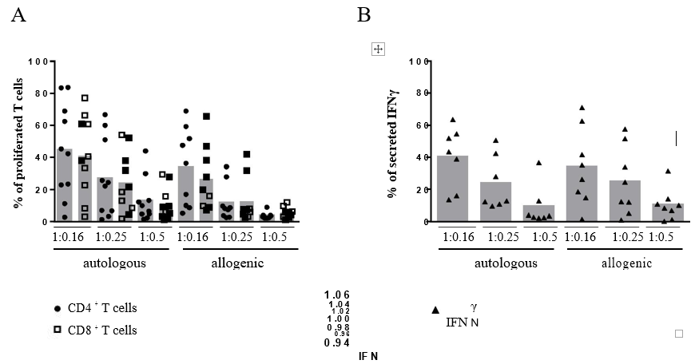
Figure S7: Comparison of autologous and allogenic PMN-MDSCs. (A) Responder PBMCs were labelled with CFSE, stimulated with OKT3 and IL-2. PMN-MDSCs were isolated by magnetic separation with CD66b antibodies and appropriate MicroBeads. Stimulated PBMCs were cultured in different ratios of 1:0.16, 1:0.25 or 1:0.5 with PMN-MDSCs from an autologous or allogenic donor as indicated. After 4 days of incubation, the proliferation of T cells was analyzed by flow cytometry. Each donor of responder PBMCs is presented by ● for CD4⁺ and CD8⁺ T cells. (B) Supernatants from the co-cultured PBMCs with PMN-MDSCs were collected after 4 days and assessed for IFNγ levels by ELISA. Each indicates the level of IFNγ from a single donor of responder PBMCs.

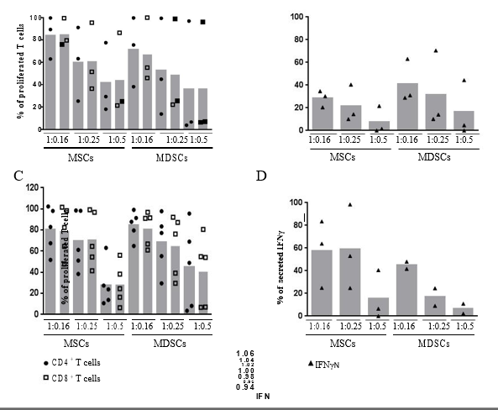

Figure S8: Comparison of MSCs and PMN-MDSCs from the same donor in an autologous and allogenic setting. (A and C) First, MSCs were isolated and cultured for up to 10 passages. PBMCs from heparinized fresh blood of the same donor were isolated by density gradient centrifugation. PMN-MDSCs were isolated from these PBMCs by magnetic separation with CD66b antibodies and appropriate MicroBeads. Additionally, responder PBMCs were labeled with CFSE, stimulated with OKT3 and IL-2. Stimulated PBMCs were cultured with MSCs or PMN-MDSCs from the same donor in different ratios of 1:0.16, 1:0.25 or 1:0.5. After 4 days of incubation, the proliferation of T cells was analyzed by flow cytometry. Each donor of responder PBMCs is presented by ● for CD4⁺ and by □ for CD8⁺ T cells. (B and D) Supernatants from the co-cultured PBMCs with MSCs or PMN-MDSCs were collected after 4 days and tested by IFNγ ELISA. Each indicates the level of IFNγ from a single donor of responder PBMCs. In Figure S8 A-B, the autologous experimental setting is presented with responder PBMCs, MSCs, and PMN-MDSCs from the same donor, whereas in Figure S8 C-D the allogenic setting is shown with stimulated PBMCs from another donor, but still MSCs and PMN-MDSCs were obtained from the same donor.

