Supplementary Information
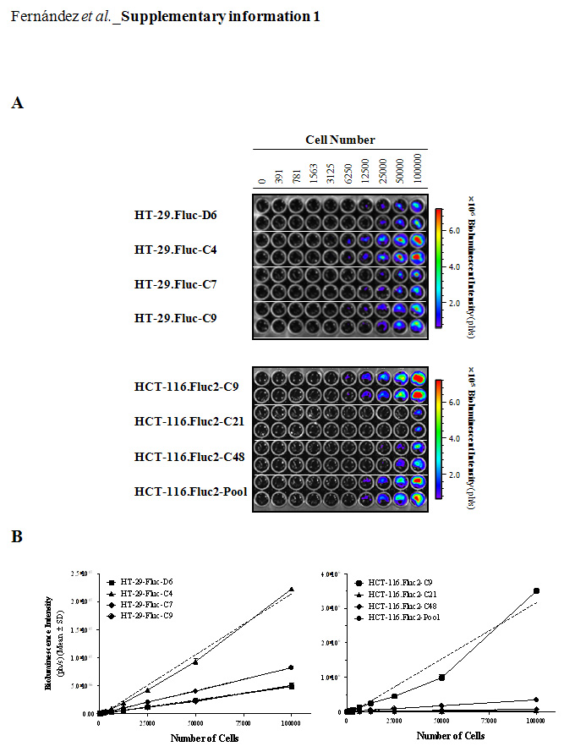
Supplementary information 1: In vitro BLI of HT-29 and HCT 116 bioluminescent cell variants.
A) Representative bioluminescent images of serial two-fold dilutions of HT-29 and HCT 116 variants are shown. B) Quantification of the bioluminescence intensity (in ph/s) from images acquired 15 min after D-luciferin addition (150 μg/mL) with the IVIS® Spectrum system, confirmed that there is a linear correlation between BLI light production and tumor cell number. The dashed lines represent the linear regression fits for each corresponding variant. The clones HT-29.Fluc-C4 and HCT 116.Fluc-C9 were the brightest cell clones among all variants tested.
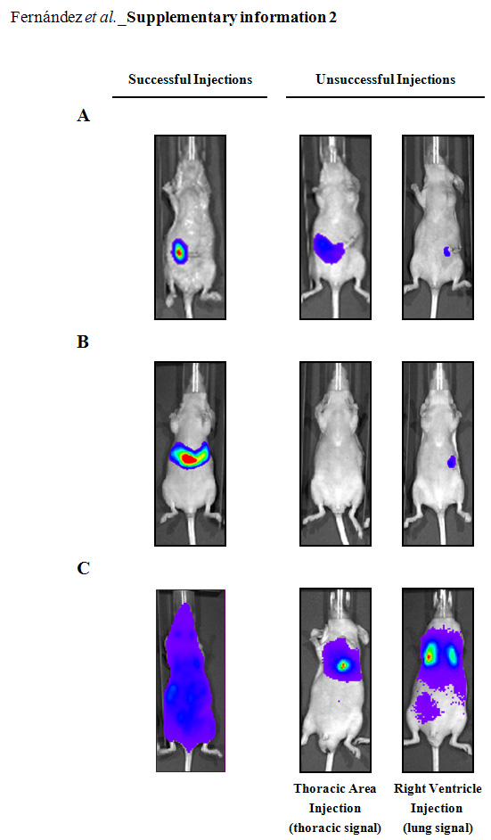
Supplementary information 2: Cellular implant efficiency.
Selected bioluminescent ventral view images from representative successful and unsuccessful injections are shown for the orthotopic intracecum wall (A), intrasplenic (B) and intracardiac (C) mouse models. For the intracecun model, a satisfactory injection into the cecal wall is identified by a localized and unique bioluminescent signal into the abdominal cavity. For the intrasplenic model, a successful injection is detected by a localized bioluminescent signal in the anatomic position of the liver, and mice with no or very low bioluminescent signal were also excluded. For the intracardiac model, a proper injection into the left ventricle is visualized by an immediate but transient systemic bioluminescent signal over the entire animal. In contrast, an unsuccessful implantation produced a more localized signal generally isolated and sustained over time solely within the thoracic region of the animal. If the cells are injected into the right ventricle, tumor cells pass directly to the lungs through the pulmonary artery, and a clear pulmonary morphology is observed.
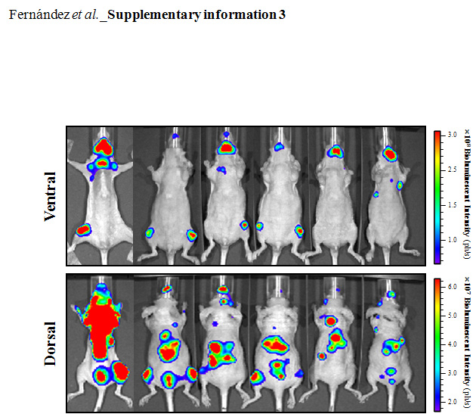
Supplementary information 3: Multiple metastases detected in vivo following intracardiac injection of HT-29 bioluminescent cells.
Representative in vivo images of ventral and dorsal mouse views taken on day 23rd after cell implantation are shown. Images from each corresponding view were set at the same pseudocolor scale to show relative bioluminescent changes between mice.

