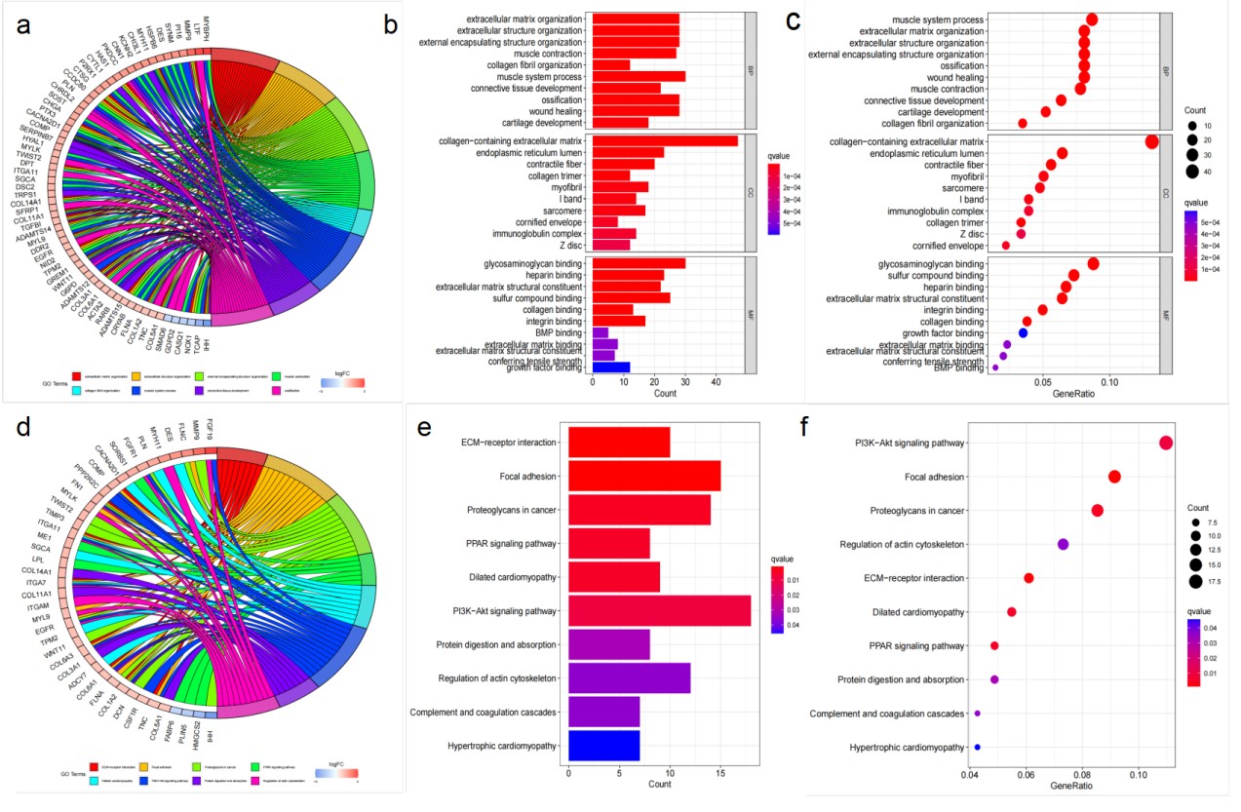
Figure S1 Fatty acid metabolism gene GO and KEGG enrichment pathway
(a) Functional enrichment analysis of differentially expressed fatty acid metabolism GO .(b) Functional enrichment bar graph of differentially expressed fatty acid metabolism GO: red: high enrichment; blue: low enrichment. (c) Bubble Diagram of Differential Expression Fatty Acid Metabolic GO Function Enrichment Pathway. red: high enrichment; blue: low enrichment. (d)KEGG enrichment analysis of differentially expressed genes in bladder cancer. (e) KEGG enrichment analysis of bladder cancer differential expression gene enrichment function bar graph. red: high enrichment; blue: low enrichment. (f) KEGG enrichment analysis of Bubble Diagram of DEGs enrichment pathway in bladder cancer. red: high enrichment; blue: low enrichment.

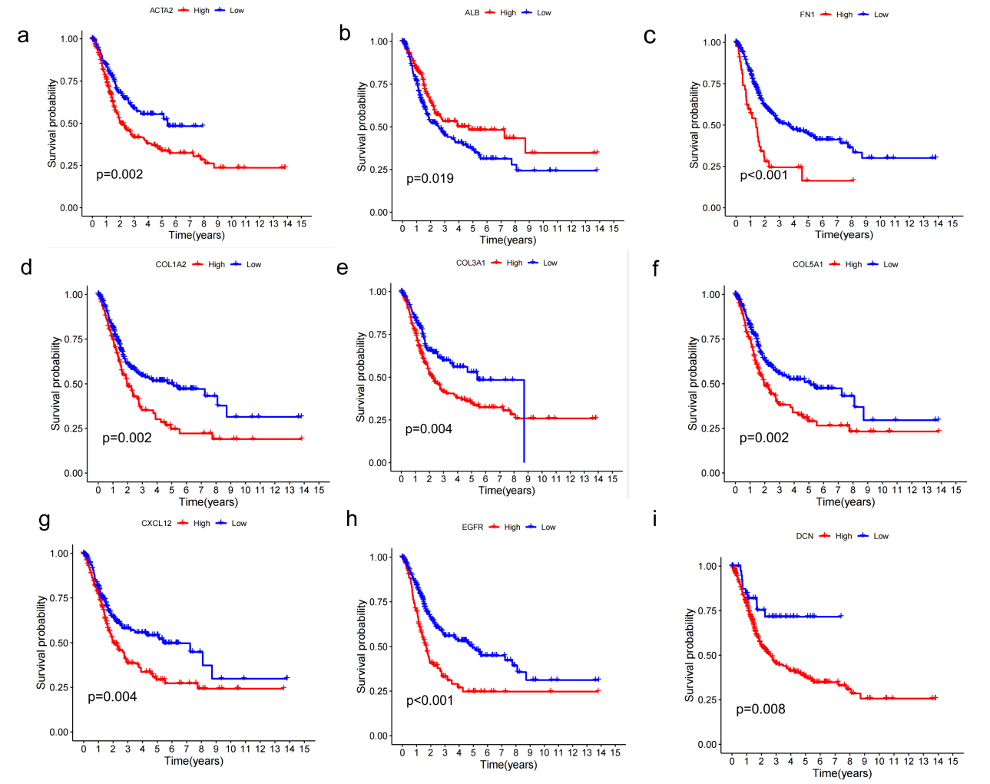
Figure S2 Relationship between single gene expression of fatty acid metabolism gene and survival and prognosis of bladder cancer patients.
The curve between ACTA2(a), ALB(b), FN1(c), COL1A2(d), COL3A1(e), COL5A1(f), CXCL12(g), DCN(h), and EGFR(i) expression and survival rate of bladder cancer patients: blue: low expression; Red: High expression.

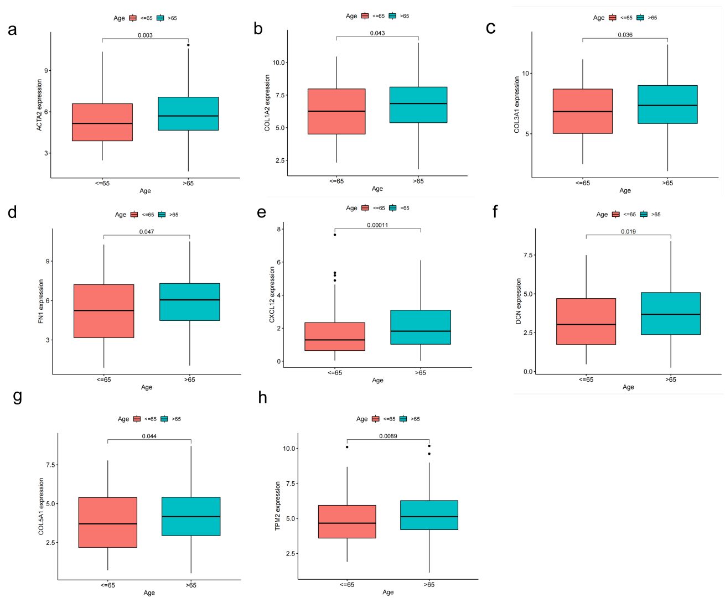
Figure S3 Single gene expression of fatty acid metabolism gene and clinical characteristics of bladder cancer patients: correlation with age.
Clinical characteristics of bladder cancer patients: the relationship between age and single gene: ACTA2(a), COL1A2(b), COL3A1(c), FN1(d), CXCL12(e), DCN(f), COL5A1(g), and TPM2(h) expression. red: old age (>65); blue: young (<65)

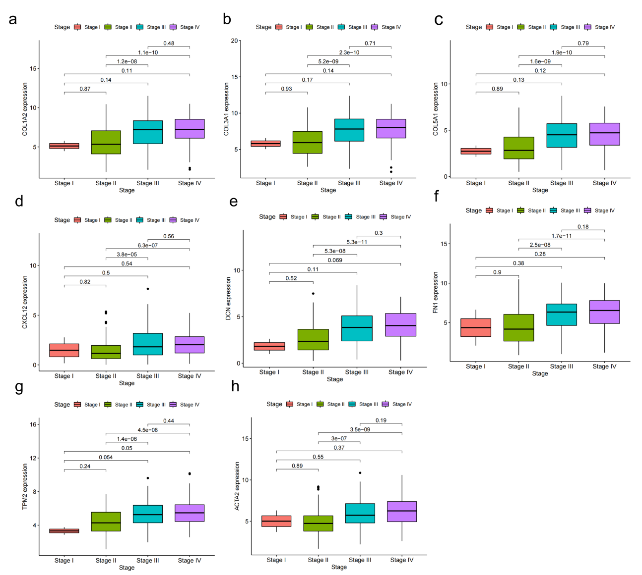
Figure S4 Single gene express on of fatty acid metabolism gene and clinical characteristics of bladder cancer patients:correlation with st age .
Clinical characteristics of bladder cancer patients : relationship between
st age and single gene: COL1A2( a) , COL3A1(b) , COL5A1( c) , CXCL12(d) , DCN( e) , FN1(f) , TPM2( g) , and ACTA2(h) expresson . red : Stage 1; green: Stage 2; blue: Stage 3; purple: Stage 4 .

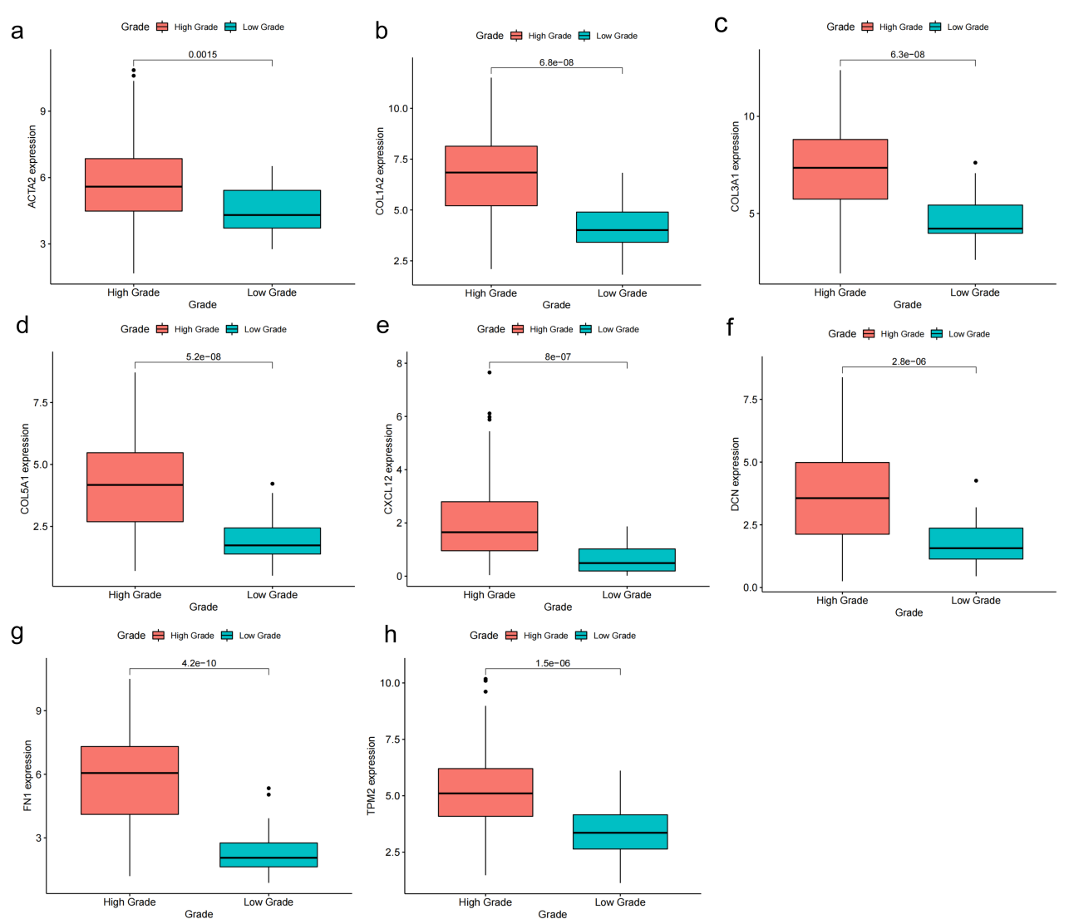
Figure S5 Single gene express on of fatty acid metabolism gene and clinical characteristics of bladder cancer patients：correlation with grade .
Clinical characteristics of bladder cancer patients: relationship between
grade and single gene: ACTA2(a), COL1A2(b), COL3A1(c), COL5A1(d), CXCL12(e), DCN(f), FN1(g)and TPM2(h)express on red : high Grade;
blue: low Grade .

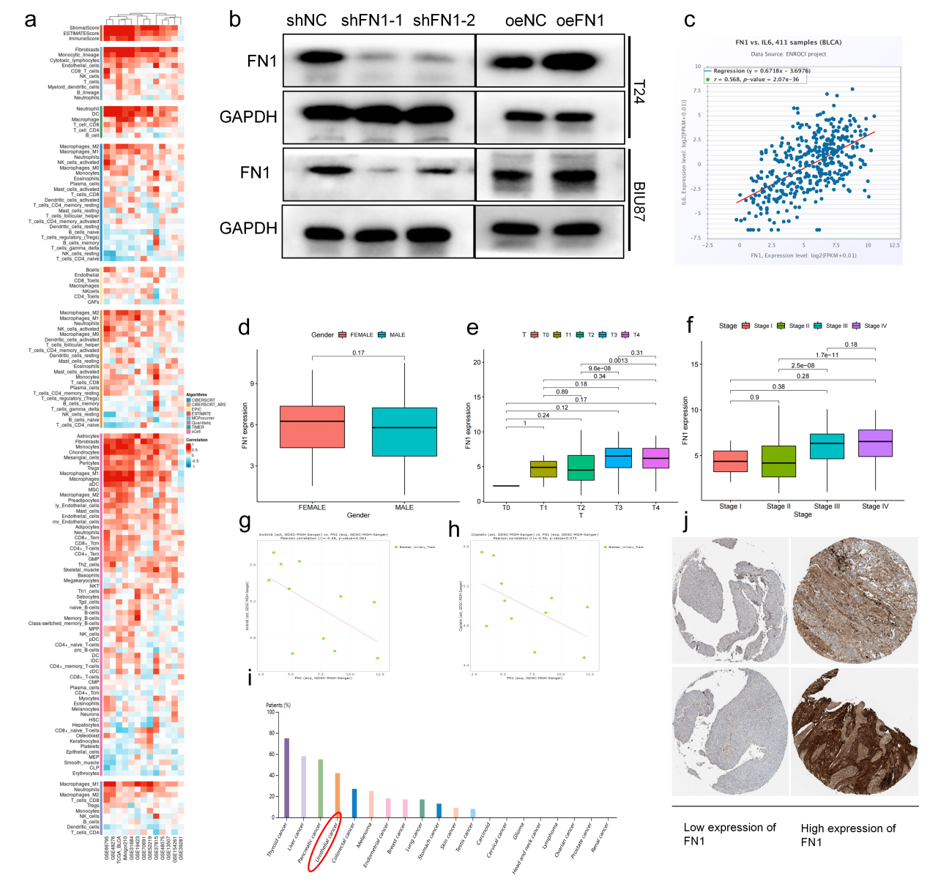

Figure S: Correlation of FN1 expression in bladder cancer with clinical features, immunoinfiltrating cells, and clinical treatment
The correlation between immune cell infiltration and FN1 expression in bladder cancer was analyzed in biological information database. (b) Efficiency verification of reducing or increasing FN1 expression in bladder cancer cell lines T24 and BIU87. (c) ENROCI:There was a positive correlation between the expression of FN1 and IL6 in bladder cancer. (g) Relative sensitivity of axitinib to FN1 expression in bladder cancer patients. (h) Relative sensitivity of cisplatin to FN1 expression in bladder cancer patients. (i) Bioinformatics analysis: The proportion of increased FN1 expression in the tumor tissues of pancarcinoma patients. (j) Low or high expression of FN1 in immunohistochemical sections of low-grade bladder cancer.

