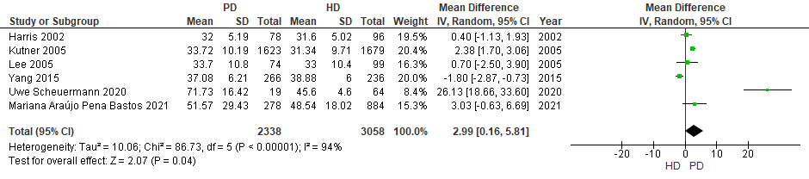
S1: Patients scores on PCS subdomain of SF-36.

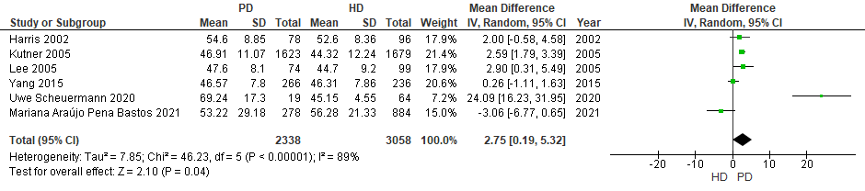
S2: Patients scores on MCS subdomain of SF-36

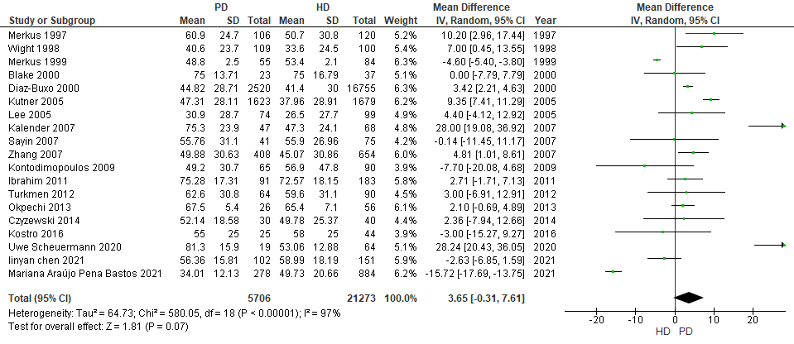
S3: Patients scores on physical functioning subdomain of SF-36
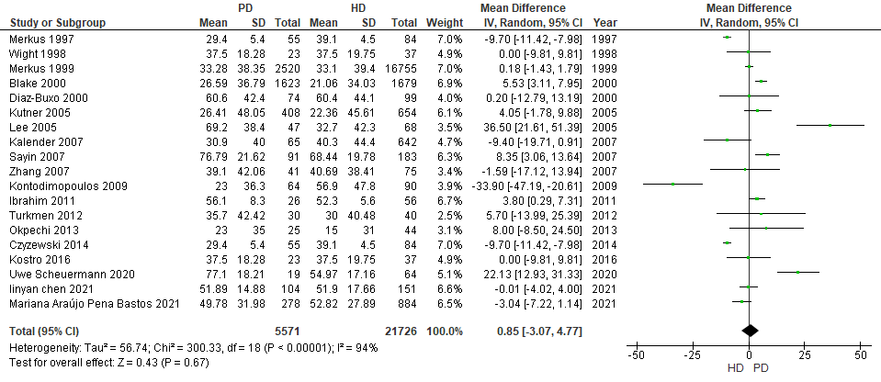
S4: Patients scores on role limitation due to physical health subdomain of SF-36
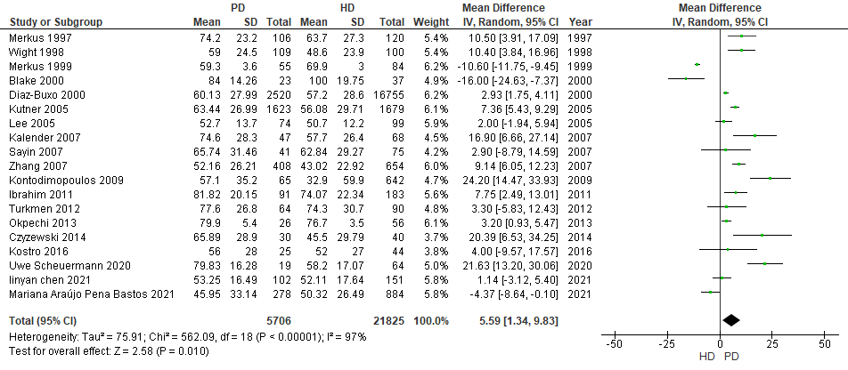

S5: Patients scores on pain subdomain of SF-36.

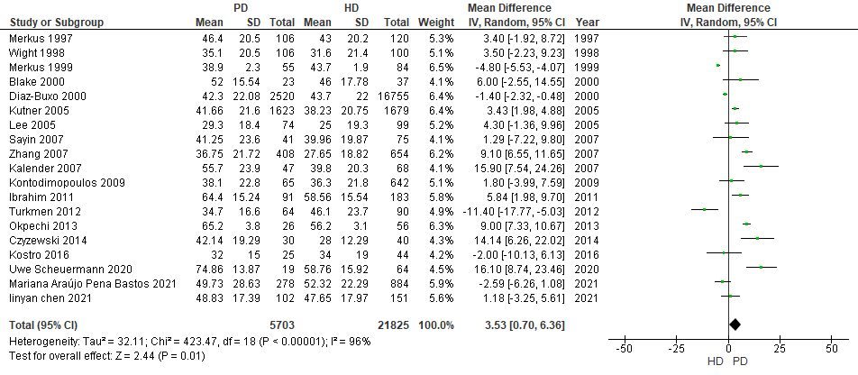
S6: Patients scores on general health subdomain of SF-36

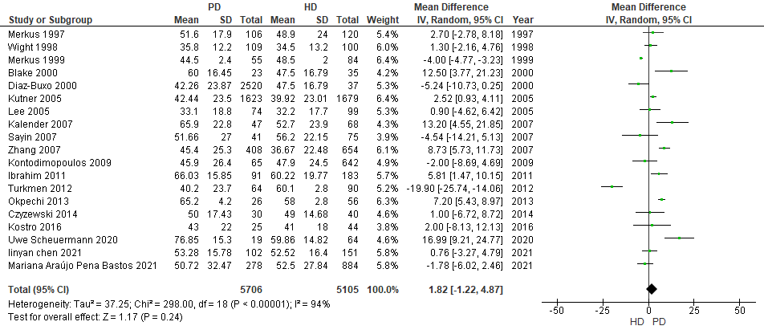
S7: Patients scores on Energy subdomain of SF-36

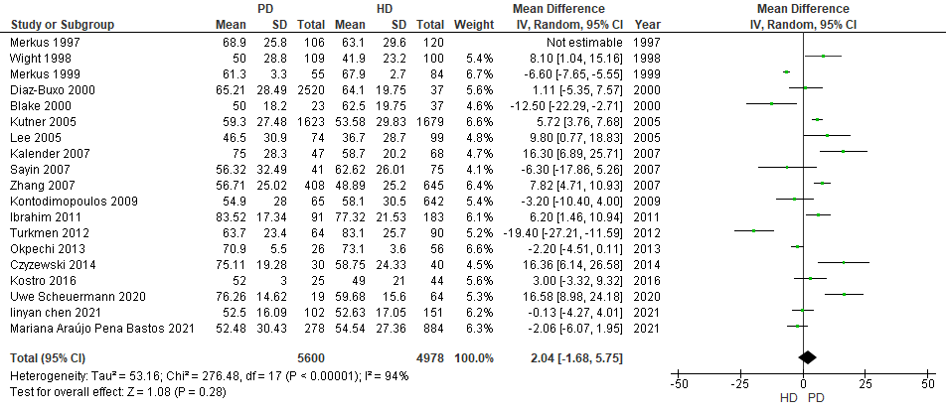
S8: Patients scores on social functioning subdomain of SF-36
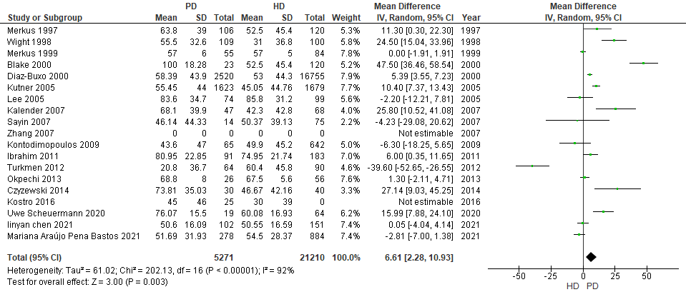
S9: Patients scores on role limitations due to emotional problems subdomain of SF-36
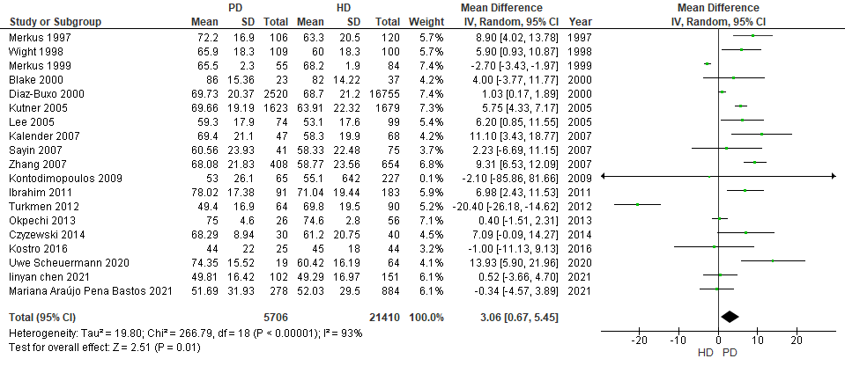
S10: Patients scores on emotional well-being subdomain of SF-36

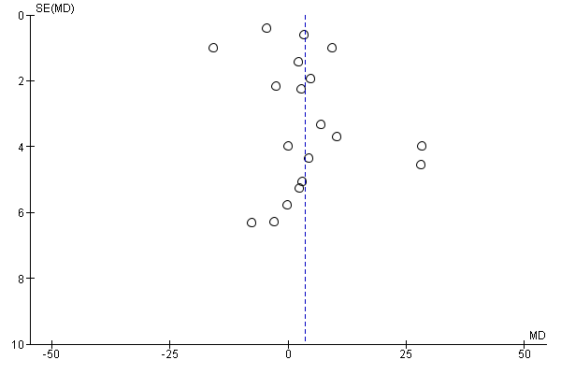

S11: Funnel plot of publication bias for SF-36

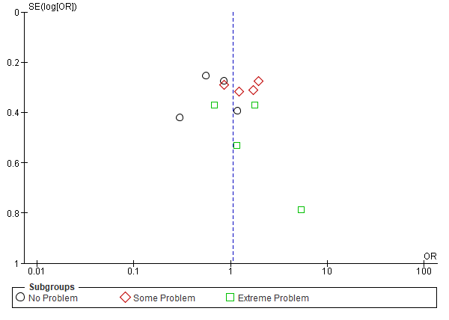

S12: Funnel plot of publication bias for EQ-D5

Supplementary Table 1: Quality assessment using JBI critical appraisal checklist

Author (Year) | Inclusion Criteria | Study subjects and setting description | Measurement of exposure | Standardized measurement | Confounding factors | Outcomes measurement reliable | Appropriate statistical analysis
Merkus (1997) | Yes | Yes | No | Yes | Yes | No | Yes
Merkus (1999) | Yes | Yes | No | Yes | Yes | No | Yes
Wight (1998) | No | Yes | No | Yes | Yes | No | Yes
Blake (2000) | Yes | Yes | No | No | No | No | No
Diaz-Buxo (2000) | No | Yes | No | No | No | No | Yes
Harris (2002) | Yes | Yes | No | No | Yes | No | Yes
Wasserfallen (2004) | No | No | Yes | No | No | No | No
Kutner (2005) | Yes | Yes | Yes | Yes | Yes | Yes | Yes
Lee (2005) | Yes | Yes | Yes | No | No | No | Yes
Kalender (2007) | No | No | No | No | No | Yes | Yes
Zhang (2007) | No | No | No | No | No | No | Yes
Sayin (2007) | Yes | Yes | No | No | No | Yes | Yes
Borowiak (2009)
Kontodimopoulos (2009) | No | Yes | No | No | No | No | Yes
Ibrahim (2011) | No | No | No | No | No | No | No
Turkmen (2012) | Yes | Yes | Yes | Yes | Yes | Yes | Yes
Okpechi (2013) | Yes | Yes | No | Yes | Yes | No | Yes
Czyzewski (2014) | Yes | Yes | No | Yes | Yes | No | Yes
Yang (2015) | Yes | Yes | Yes | No | Yes | Yes | Yes
Ramos (2015) | No | Yes | No | No | No | Yes | Yes
Kostro (2016) | Yes | No | No | No | No | No | Yes
Chang (2016) | Yes | Yes | Yes | Yes | Yes | Yes | Yes
Uwe Scheuermann (2020) | No | No | No | No | No | No | Yes
Iijuan Zhang (2020) | Yes | Yes | No | No | No | No | No
Iinyan Chen (2021) | Yes | Yes | Yes | No | No | Yes | Yes
Mariana Araújo Pena Bastos(2021) | No | Yes | No | No | Yes | No | Yes
Ika Setyo Rini (2021) | No | No | No | No | No | No | No

