Supporting information：
- Chem. 3D for catalyst (1-4):
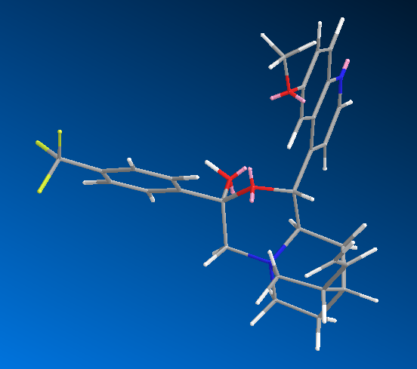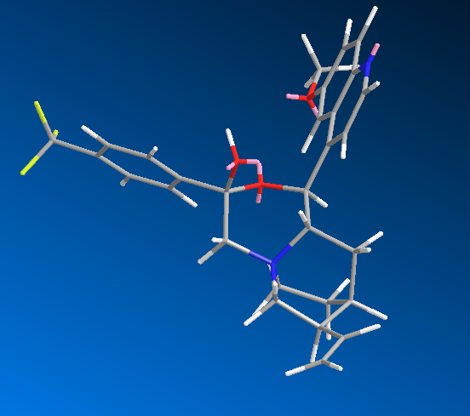
1: [64.5943 kcal/mol] & 2: [67.3417kcal/mol]
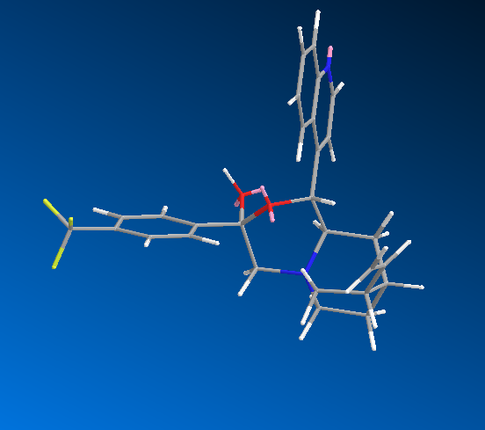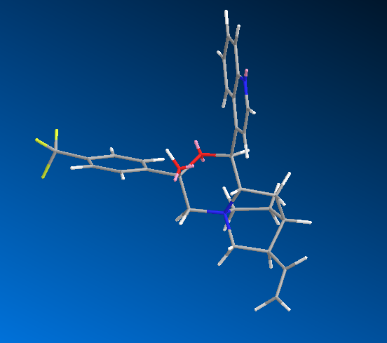
3: [62.4002 kcal/mol] & 4: [62.0021kcal/mol]
(1 corresponds to Quinine, 2 corresponds to Quindine, 3 corresponds to Cinchonidine, 4 corresponds to Cinchonine)

- Typical synthesis of catalyst 3: To a solution of cinchonidine (0.735 g, 2.5mmol) in THF (15 ml) was added 5 (0.668 g, 2.5 mmol), and the mixture was stirred at room temperature for 8 hours. Then filtered and washed the solids with THF to afford 1.384 g desired product with light yellow color (98.72% yield). ¹H-NMR(500MHz, CD₃COCD₃) δ: 9.02(d, J=4.3Hz, 1H), 8.61(d, J=8.35Hz, 1H), 8.22(d, J=8.15Hz, 2H), 8.13-8.11(m, 1H), 8.09(d, J=4.3Hz, 1H), 7.96(d, J=8.35Hz, 1H), 7.82(d, J=8.15Hz, 2H), 7.68-7.65(m, 1H), 6.14-6.07(m, 1H), 5.69-5.67(m, 1H), 5.30-5.26(m, 1H), 5.18-5.16(m, 1H), 5.03-5.01(m, 1H), 4.48-4.42(m, 2H), 4.24-4.20(m, 1H), 4.15-4.10(m, 1H), 3.24-3.19(m, 1H), 3.13-2.87(m, 1H), 2.16-2.13(m, 1H), 2.11-2.10(m, 1H), 2.01-1.99(m, 1H), 1.88-1.85(m, 1H), 1.46-1.39(m, 1H), 1.22-1.19(m,1H). ESI-MS: [M-Br] ⁺:481.3, [M] ⁻:561.3. [α]_{D}²⁰ = -310.5°(c = 0.20 in CH₂Cl₂).
Data for 1 and 2: 1, 99%(yield),¹H-NMR (500MHz, CD₃COCD₃) δ: 8.83(d, J=4.4Hz, 1H), 8.18(d, J=8.0Hz, 2H), 8.00(d, J=4.4Hz, 1H), 7.98-7.92(m, 1H), 7.82(d, J=8.0Hz, 2H), 7.40-7.35(m, 2H), 6.03-6.10(m, 1H), 5.94-5.89(m, 1H), 5.55-5.52(m, 1H), 5.28-5.25(m, 1H), 5.07-5.22(m, 1H), 4.44- 4.51(m, 1H), 4.27-4.24(m, 2H), 4.16(s, 3H), 4.07-4.0 (m, 2H), 3.20-3.16(m, 1H), 2.98-2.96(m, 1H), 2.16-2.33(m, 2H), 1.90-1.84(m, 1H), 1.43-1.37(m, 1H), 1.29-1.27(m, 1H). [α]_{D}²¹ = -324.9°(c = 0.20 in CH₂Cl₂). ESI-MS: [M] ⁻:591.3.
2, 97.22%(yield), ¹H-NMR (500MHz, CD₃COCD₃) δ: 8.86(d, J=4.4Hz, 1H), 8.22(d, J=8.0Hz, 2H), 8.05(d, J=4.4Hz, 1H), 7.99(d, J=9.2Hz, 1H), 7.85(d, J=8.0Hz, 2H), 7.40(d, J=9.2Hz, 1H), 7.39-7.36(m, 1H), 5.80- 5.70(m, 2H), 5.32-5.30(m, 1H), 5.11-5.09(m, 1H), 5.05-5.01(m, 1H), 4.36-4.28(m, 2H), 4.16(s, 3H), 4.11-4.07(m, 1H), 3.84-3.80(m, 1H), 3.32-3.37(m, 1H), 2.74-2.72(m, 1H), 2.30-2.20(m, 1H), 2.12-2.08 (m, 1H), 1.98-1.96(m, 1H), 1.80-1.78(m, 1H), 1.54-1.49(m, 1H), 1.18-1.12 (m, 1H). [α]_{D}²² = +314.6°(c = 0.20 in CH₂Cl₂). ESI-MS: [M] ⁻:591.3
2. Typical asymmetric sulfenylation of glycine derivatives for entry 3: To a mixture of 6 (0.148 g, 5 mmol), catalyst 3 (10% mol, 28 mg) in 5 ml toluene was added 1.1eq sulfenylation reagent and 20eq 50% KOH aqueous at 10 °C. The reaction mixture was stirred vigorously at the same temperature for 18 hours. Then added 5 ml water, and separated two phases. Aqueous layer was extracted with CH₂Cl₂ twice. The organic extracts were washed with brine and dried over Na₂SO₄. Evaporation of solvents and purification of the residual oil by column chromatography on silica gel (PE/EA = 30:1) gave the sulfenylation product (131 mg, 65% yield) as a colorless oil. 7a:1H-NMR (500MHz, CDCl3) 1HNMR: 7.83-7.80 (m, 2H), 7.52-7.33 (m, 8H), 7.26-7.21 (m, 5H), 5.71 (m, 1H), 1.38 (s, 9H). HPLC analysis retention time: 10.72 min (major), 15.31 min (Daicel Chiralcel OD-H, hexane/i-PrOH = 99.5/0.5, flow rate = 0.5 mL/min).

