Supplementary Material
Figure S1: Br-PhenDC3 synthetic pathway: a) 1.8 eq. 1, 1.0 eq. Br₂, oleum 20%, 135 °C 20 h, 93%; b) 1 eq. 2, 8 eq. NCS, benzoic acid, CCl₄/CHCl₃, 16 h Δ; c) 1) 1 eq. 3, 46 eq. H₂SO₄ 98 %., 80-90 °C 6 h, 2) H₂O, 2 h Δ; d) 1 eq. 4, 2.1 eq. 3-aminoquinoline, 2.1 eq. ECD, 0.2 eq. HOBt, DMF, RT overnight; e) 1 eq. 5, 35.3 eq. MeOTf, ClCH₂CH₂Cl, Δ 16 h. Materials and methods and details for each step are described below:

¹H and ¹³C spectra were recorded at 25°C on a Bruker Avance 300 using TMS as internal standard. Deuterated CDCl₃ and [D₆] DMSO were purchased from SDS. The following abbreviations are used: singlet (s), doublet (d), triplet (t) and multiplet (m). Low resolution mass spectrometry (ESI-MS) was recorded on a micromass ZQ 2000 (waters). High resolution mass spectrometry (ESI-MS) and elemental analyses were provided by the I.C.S.N. (Institut de Chimie des Substances Naturelles, Gif-sur-Yvette). TLC analysis was carried out on silica gel (Merck 60F-254) with visualization at 254 and 366 nm. Melting points were taken on a Kofler melting point apparatus and are uncorrected. Preparative flash chromatography was carried out with Merck silica gel (Si 60A, 35-70 µm) using Dichloromethane/Methanol mixtures unless otherwise state.

Reagents and chemicals were purchased from Sigma-aldrich, Acros or Alfa-aesar unless otherwise stated: 2,9-Dimethyl-1,10-phenanthroline, and 3-Aminoquinoline are commercially available. Solvents were purchased from SDS.
TO (thiazole orange) and cacodylic acid were purchased from Aldrich and used without further purification. Stock solutions of TO (2 mM in DMSO) and ligands (500 mM in DMSO) were used for G4-FID assay.
An XBridge C18, 3.5μm, 3.0 x 100 mm (Waters) column was used. HPLC injection: flow 0.75 mL/min; gradient elution: eluent A% H₂O 0.1% HCOOH, eluent B% MeCN 0.1% HCOOH: 0 min (98/2), 1 min (98/2), 7 min (0/100), 9 min (100/0), 13 min (98/2).
5’ and 3’ fluorophore labelled quadruplex sequences F21T, FCEB25wtT, FCEB25-L121T, FPu24TT, and unlabelled duplex DNA ds26were synthesized and purified by RP-HPLC by Eurogentec, and stored at -20 °C as a 200 µM aqueous solution.
Synthesis of Br-PhenDC3
To achieve the synthesis of the bromo derivative BrPhenDC3, we exploited an easy synthetic pathway starting from precursor 1. We obtained the desired compound in five synthetic steps represented in Scheme 1.
5-bromo-2,9-dimethyl-1,10-phenanthroline (2)
In a 100 ml flask previously dried under vacuum, 2,9-dimethyl-1,10-phenanthroline (1, 1,790 g, 8,60 mmol) was introduced in an heavy wall tube with a Teflon screw. The reaction vessel was cooled down with ice and oleum (20%, 6 ml) and Bromine (0,244 ml, 4,73 mmol) were added. The mixture was stirred at 135°C for 20h. The reaction mixture was cooled down to room temperature, poured over ice and neutralized with NH₄OH. The mixture was extracted with EtOAc, dried over MgSO₄, and evaporated to dryness to afford 5-bromo-2,9-dimethyl-1,10-phenanthroline (2,103 g, 7,32 mmol, 85 % yield) as final product.
M. p. = 172°C; ¹H NMR (300 MHz, CDCl₃): δ= 8.53 (d, J = 8.5 Hz, 1 H), 8.04 (d, J = 8.2 Hz, 1 H), 8.03 (s, 1H), 7.58 (d, J = 8.5 Hz, 1 H), 7.50 (d, J = 8.2 Hz, 1), 2.97 (s, 3H), 2.93 (s, 3H) ppm; ¹³C NMR (75 MHz, CDCl₃): δ= 160.18, 159.88, 145.74, 144.70, 136.05, 135.32, 128.58, 127.03, 126.00, 124.25, 124.10, 119.65, 25.91, 25.62 ppm.; LC-MS (ESI-MS): m/z= 287.1 [M⁺], t = 4.45 min; HRMS (ESI-MS)C₁₄H₁₁BrN₂: 287.0186 (calculated: 287.0184 C₁₄H₁₂BrN₂⁺).
5-bromo-1,10-phenanthroline-2,9-dicarboxylic acid (4)
In a 100 ml round-bottomed flask, 5-bromo-2,9-dimethyl-1,10-phenanthroline (2, 2.00 g, 6.96 mmol), N-Chlorosuccinimide (7.44 g, 55.7 mmol), and a portion of benzoic acid (29.7 mg, 0.244 mmol) were dissolved in CCl₄ (Ratio: 4.00, Volume: 40 ml) and CHCl₃ (Ratio: 1.00, Volume: 10 ml). The mixture was refluxed for 16h, cooled to RT and then filtered. Filtrate was washed with three portions of saturated aq Na₂CO₃, dried over MgSO₄, and the solvent removed under reduced pressure. The product was purified by column chromatography in cyclohexane/DCM, gradient from 90:10 to 60:40 affording 5-bromo-2,9-bis(trichloromethyl)-1,10-phenanthroline (3, 2.030 g, 4.11 mmol, 59 % yield). Due to the low stability of compound 3, after isolation ¹H NMR and LRMS were recorded and the product submitted to the next reaction. ¹H NMR (300 MHz, CDCl₃): δ= 8.84 (d, J = 8.8 Hz, 1 H), 8.41 - 8.27 (m, 4 H) ppm; LC-MS (ESI-MS): m/z= 490.8 [M⁺] C₁₄H₅BrCl₆N₂, t = 8.52 min.
In a 250 mL round-bottomed flask, 5-bromo-2,9-bis(trichloromethyl)-1,10-phenanthroline (3, 2.030 g, 4.11 mmol) was added portion wise to sulfuric acid (10 ml, 189 mmol) 98% and the mixture was heated at 80-90°C for 6h. The reaction mixture was cooled to room temperature before careful and slow addition of drops of water, until a fine white solid precipitate. The heterogeneous mixture was refluxed for 2h, cooled to room temperature and then the precipitation of the product was induced by slow addition of water. The precipitate was collected, washed with H₂O and Et₂O affording 5-bromo-1,10-phenanthroline-2,9-dicarboxylic acid (4, 1.298 g, 3.74 mmol, 91 % yield) as white powder.
Dec. > 239 °C; ¹H NMR (300 MHz, [D₆]DMSO): δ= 8.84 (d, J = 9.0 Hz, 1 H), 8.71 (s, 1 H), 8.68 (d, J = 9.0 Hz, 1 H), 8.50 (d, J = 9.0 Hz, 1 H), 8.40 (d, J = 9.0 Hz, 1 H) ppm; ¹³C NMR (75 MHz, CDCl₃): δ= 166.12, 165.85, 149.06, 148.84, 145.31, 144.24, 137.43, 131.71, 130.55, 129.15, 124.47, 124.08, 39.85, 39.68, 39.51, 39.34, 39.18 ppm; LC-MS (ESI-MS): m/z= 345.0 [M⁻], t = 5.35 min; HRMS (ESI-MS)C₁₄H₇BrN₂O₄: 346.9673 (calculated: 346.9667 C₁₄H₈BrN₂O₄⁺).
5-bromo-N2,N9-di(quinolin-3-yl)-1,10-phenanthroline-2,9-dicarboxamide (5)
In a 100 ml flask, 5-bromo-1,10-phenanthroline-2,9-dicarboxylic acid (4, 100 mg, 0,288 mmol) and 3-aminoquinoline (87 mg, 0,605 mmol) were dissolved in DMF (5 ml). HOBt (7,79 mg, 0,058 mmol) and EDC (116 mg, 0,605 mmol) were added. No precipitation occurred and the reaction mixture was stirred at room temperature overnight. The product was precipitated by addition of H₂O. The precipitate was filtered, washed with CH₂Cl₂, with H₂O, with 1% NaHCO₃ solution and with Et₂O affording 5-bromo-N2,N9-di(quinolin-3-yl)-1,10-phenan throline-2,9-dicarboxamide (5, 153 mg, 0,255 mmol, 89 % yield) as a green powder.
Stable till 300 °C; ¹H NMR (300 MHz, [D₆]DMSO): δ= 11.87 (bs, 2 H), 9.67 (s, 2 H), 9.15 (s, 2 H), 9.04 (d, J = 9.0 Hz, 1 H), 8.89-8.84 (m, 2 H), 8.80 (d, J = 9.0 Hz, 1 H), 8.70 (d, J = 9.0 Hz, 1 H), 8.11 (m, 4 H), 7.76-7.67 (m, 4 H) ppm; LC-MS (ESI-MS): m/z= 599.8 [M⁺], 299.9 [M²⁺], t = 7.66 min; HRMS (ESI-MS)C₃₂H₁₉BrN₆O₂: 599.0835 (calculated: 599.0831 C₃₂H₂₀BrN₆O₂⁺).
3,3'-((5-bromo-1,10-phenanthroline-2,9-dicarbonyl)bis(azanediyl))bis(1-methylquinolin-1-ium) trifluoromethanesulfonate (BrPhenDC3)
In a 100 ml flask, 5-bromo-N2,N9-di(quinolin-3-yl)-1,10-phenanthroline-2,9-dicarboxamide (5, 60 mg, 0,100 mmol) was suspended in ClCH₂CH₂Cl (20 ml) under Argon. After refluxing for 2h, methyl trifluoromethanesulfonate (0,4 ml, 3,53 mmol) was added dropwise over 2 min and mixture was refluxed for 16h. The formed precipitate was filtered, washed with Et₂O affording 6,6'-((5-bromo-1,10-phenanthroline-2,9-dicarbonyl)bis(azanediyl))bis(1-methylqui nolin-1-ium) trifluoromethanesulfonate (BrPhenDC3, 79 mg, 0,085 mmol, 85 % yield) as a dark yellow powder.
Dec. > 237 °C; ¹H NMR (300 MHz, [D₆]DMSO): δ= 10.30 (s, 2 H), 9.90 (s, 2 H), 9.12 (d, J = 9.0 Hz, 1 H), 8.97-8.93 (m, 2 H), 8.88 (d, J = 9.0 Hz, 1 H), 8.80 (d, J = 9.0 Hz, 1 H), 8.58-8.53 (m, 4 H) 8.30-8.25 (m, 2H), 8.12-8.07 (m, 2 H), 7.45 (s, 6 H) ppm; ¹³C NMR (75 MHz, [D₆]DMSO): δ= 165.27, 165.01, 150.86, 150.62, 147.58, 147.50, 146.34, 145.24, 140.59, 140.54, 137.50, 137.46, 136.88, 136.70, 135.90, 135.86, 134.55, 134.48, 134.16, 133.39, 132.20, 132.02, 131.89, 131.03, 125.15, 124.71, 124.14, 123.85, 121.28, 121.11, 47.96, 42.00, 41.91, 41.83, 41.74, 41.66, 41.57, 41.50, 41.41, 41.24, 41.07, 40.91 ppm; LC-LRMS (ESI-MS): m/z= 314 [M²⁺-2Triflate], t = 4.25 min; HRMS (ESI-MS)C₃₆H₂₅BrF₆N₆O₈S₂: 777.0712 (calculated: 777.0743 C₃₅H₂₅BrF₃N₆O₅S⁺).
Table S1: Percentage of cell growth inhibition ± standard error. Cytotoxicity of Br-PhenDC3 and PhenDC3 in DMSO performed in triplicate at 10⁻⁵ M on KB (keratin-forming tumor cell line HeLa), A549 (adenocarcinomic human alveolar basal epithelial cells), MCF7 (human breast adenocarcinoma cell line), MRC5 (human fetal lung fibroblast cells), HCT116 (human colon cancer cell line) cell lines. Cytotoxicity of PhenDC3 in DMSO performed in triplicate at 10⁻⁵ M (bold) on KB, A549, and MRC5 cell lines.
 | KB | A549 | MCF7 | MRC5 | HCT116
Br-PhenDC3 | 10±5 | 33±1 | 45±11 | 38±1 | 15±7
PhenDC3 | 47±6  14±8 | 55±4  6±19 | 26±8 | 75±1  8±8 | 23±4

Figure S2: ImageJ macro to determine statistically significant Br signal at confidence level p=0.9999.

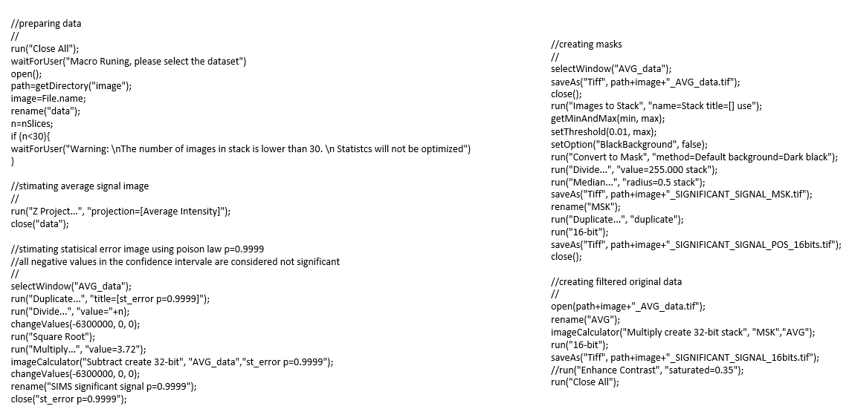

Figure S3: NanoSIMS analysis. A) Numerical zoom on five chromosomes showing the presence of bands depicting a significant (p=0.9999) Br signal at equivalent positions in chromatids. Upper row P significant (p=0.9999) signal, central row Br significant (p=0.9999), bottom row overlay of Br (red) and P (green) significant signals. Scale bar 4 µm. B) Profiles of the significant (p=0.9999) Br integrated signal (along 20px thick) for each one of the chromatids in chromosomes (CR1-CR5). For each plot, red line corresponds to the chromatid on the left and green line to the chromatid on the right for each chromosome. Arrows point to the position of maxima for each curve.
