**Additional Document**

**Supplementary Table 1.**  **Results of Mendelian randomization heterogeneity test**

|  |  |  |  |  |  |
| --- | --- | --- | --- | --- | --- |
| **Outcome** | **Exposure** | **Method** | **Q** | **Q_df** | ***Q_pval*** |
| finn_Scoliosis | ukb_Strabismus | MR Egger | 37.40 | 42 | *0.673* |
| finn_Scoliosis | ukb_Strabismus | Inverse variance weighted | 40.64 | 43 | *0.574* |
| finn_Scoliosis | finn_Strabismus | MR Egger | 11.20 | 13 | *0.594* |
| finn_Scoliosis | finn_Strabismus | Inverse variance weighted | 11.86 | 14 | *0.617* |

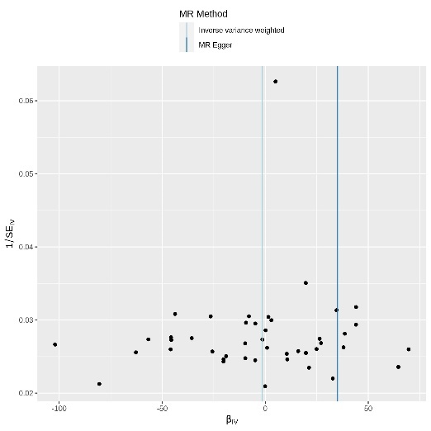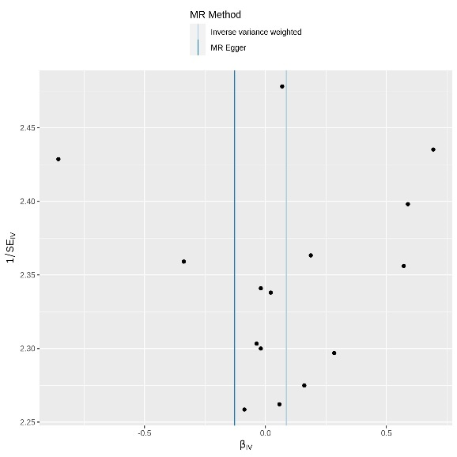**A**  **B**

**Supplementary Figure 1****. Funnel plot of heterogeneity test results was analyzed by MR Method.**

( (A) Funnel plot of finn_Scoliosis and ukb_Strabismus; (B) Funnel plot of finn_Scoliosis and finn_Strabismus.)

**Supplementary Table 2** **Directional horizontal pleiotropy test**

|  |  |  |  |
| --- | --- | --- | --- |
| **Exposure** | **Egger_intercept** | **SE** | **P** |
| ukb_Strabismus | -0.054 | 0.030 | *0.079* |
| finn_Strabismus | 0.034 | 0.042 | *0.430* |

**A B**

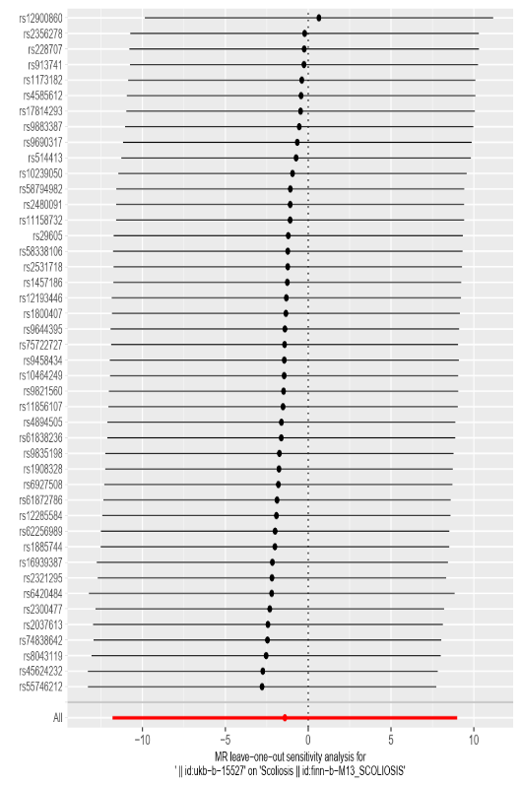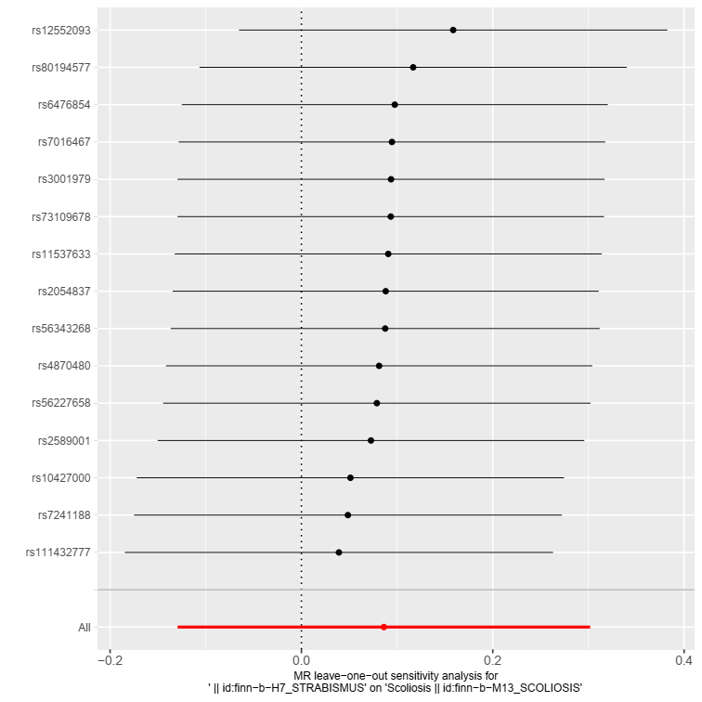

**Supplementary Figure 2.**  **Sensitivity analysis results of "Leave-one-out"**

((A) Sensitivity analysis results of finn_Scoliosis and ukb_Strabismus (B) Sensitivity analysis results of finn_Scoliosis and finn_Strabismus.)

**Supplementary Table 3. Results of Mendelian random heterogeneity test for strabismus subsets**

|  |  |  |  |  |  |  |  |
| --- | --- | --- | --- | --- | --- | --- | --- |
| **outcome** | **exposure** | | | **method** | **Q** | **Q_df** | ***Q_pval*** |
| finn_Scoliosis | | Ccs | MR Egger | | 20.09 | 23.00 | *0.636* |
| finn_Scoliosis | | Ccs | Inverse variance weighted | | 20.76 | 24.00 | *0.653* |
| finn_Scoliosis | | Dcs | MR Egger | | 24.61 | 20 | *0.217* |
| finn_Scoliosis | | Dcs | Inverse variance weighted | | 24.61 | 21 | *0.264* |
| finn_Scoliosis | | Os | MR Egger | | 13.33 | 17 | *0.714* | |
| finn_Scoliosis | | Os | Inverse variance weighted | | 13.42 | 18 | *0.766* | |
| finn_Scoliosis | | Osus | MR Egger | | 15.43 | 9 | *0.080* | |
| finn_Scoliosis | | Osus | Inverse variance weighted | | 17.07 | 10 | *0.073* | |

*Note: Convergent concomitant strabismus (Ccs); Divergent concomitant strabismus (Dcs); Other specified and unspecified strabismus (Osus); Other strabismus(Os).*

**A B**

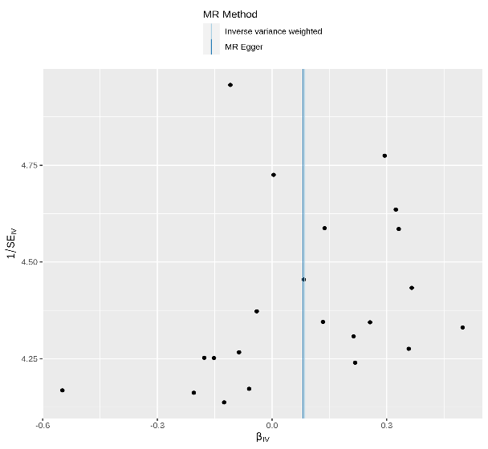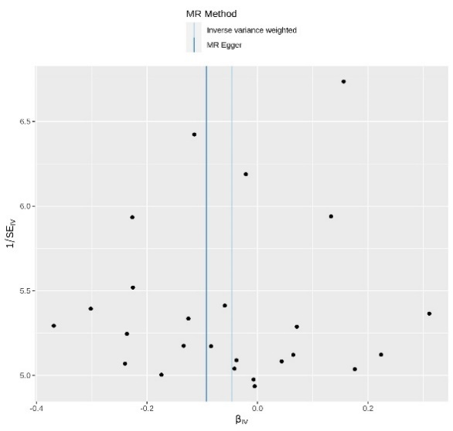

**C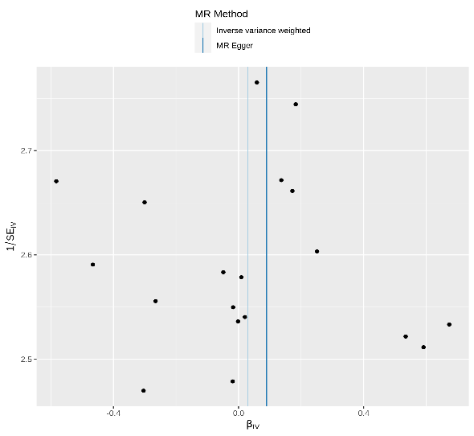 D**

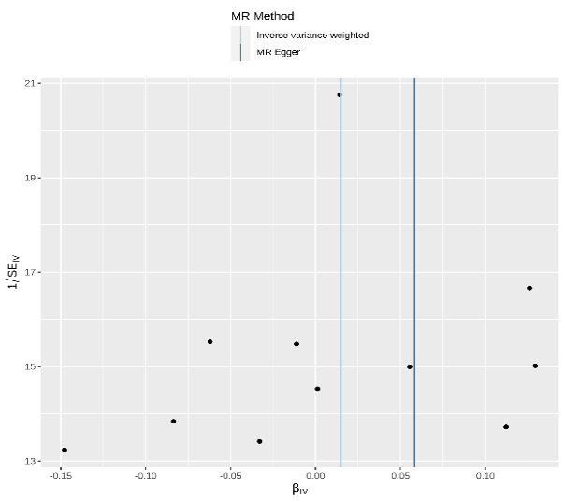

**Supplementary Figure 3. Funnel plot of heterogeneity test results was analyzed by MR Method.**

((A) Funnel plot of finn_Scoliosis and Ccs; (B) Funnel plot of finn_Scoliosis and Dcs; (C) Funnel plot of finn_Scoliosis and Os; (D) Funnel plot of finn_Scoliosis and Osus.)

**Supplementary Table 4. Directional horizontal pleiotropy test**

|  |  |  |  |
| --- | --- | --- | --- |
| **Exposure** | **Egger_intercept** | **SE** | ***P*** |
| Ccs | 0.020 | 0.025 | *0.425* |
| Dcs | 0.001 | 0.035 | *0.973* |
| Os | -0.010 | 0.031 | *0.764* |
| Osus | -0.065 | 0.067 | *0.354* |

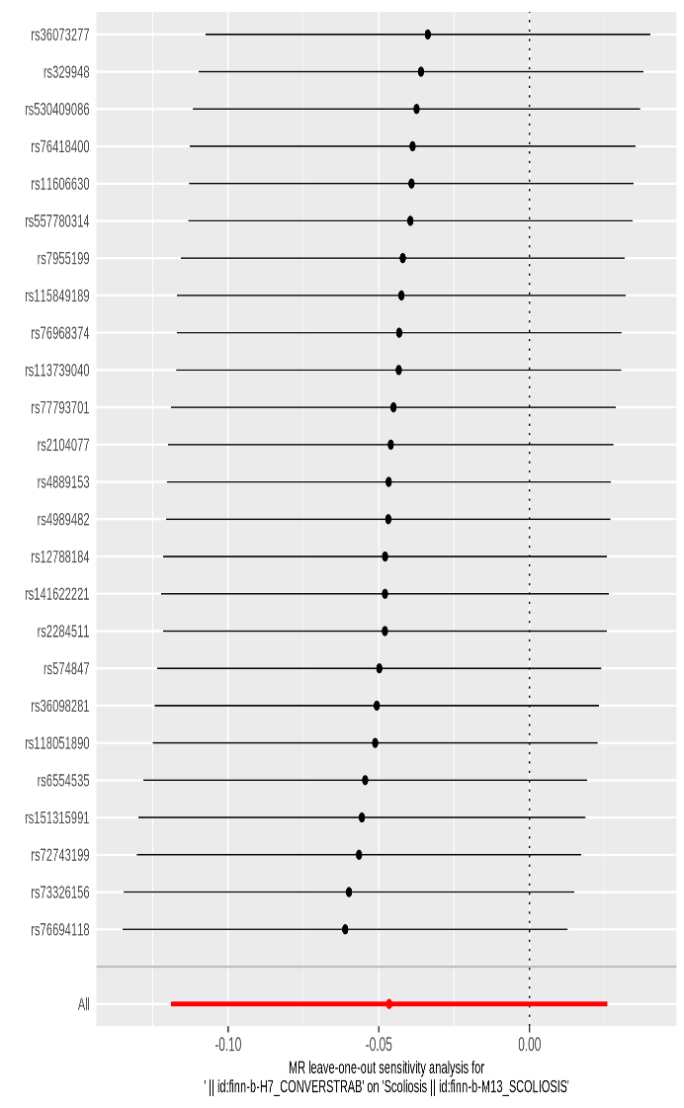**A B**

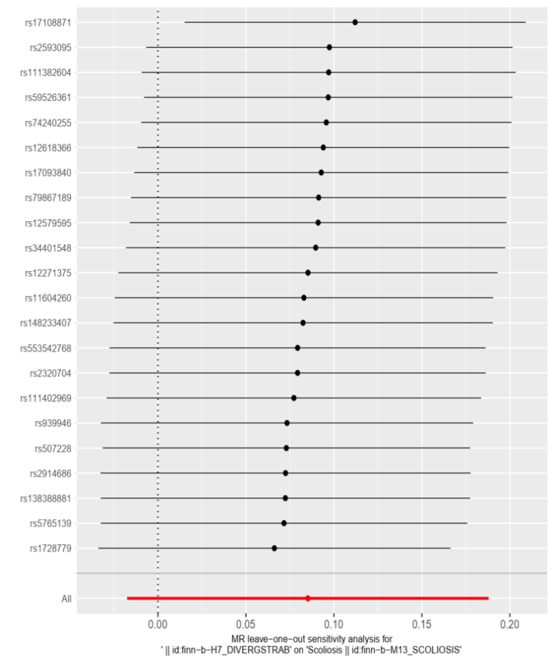

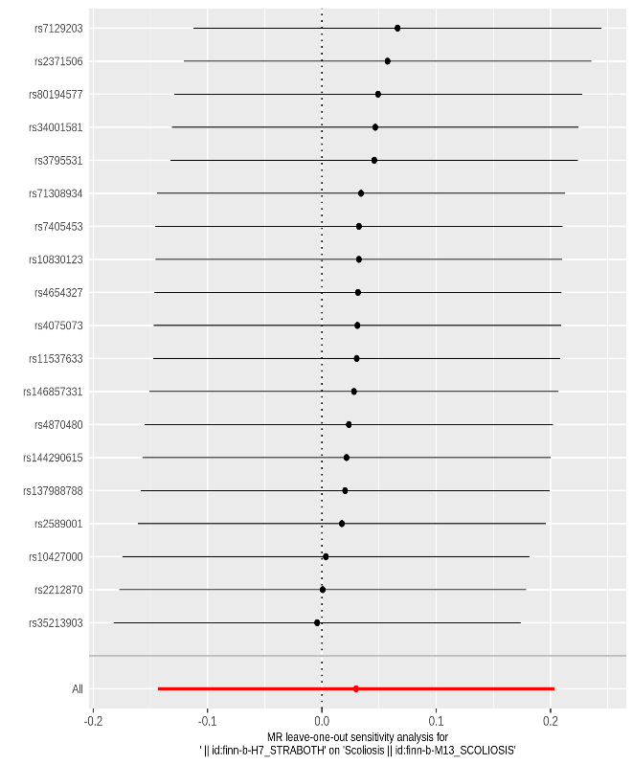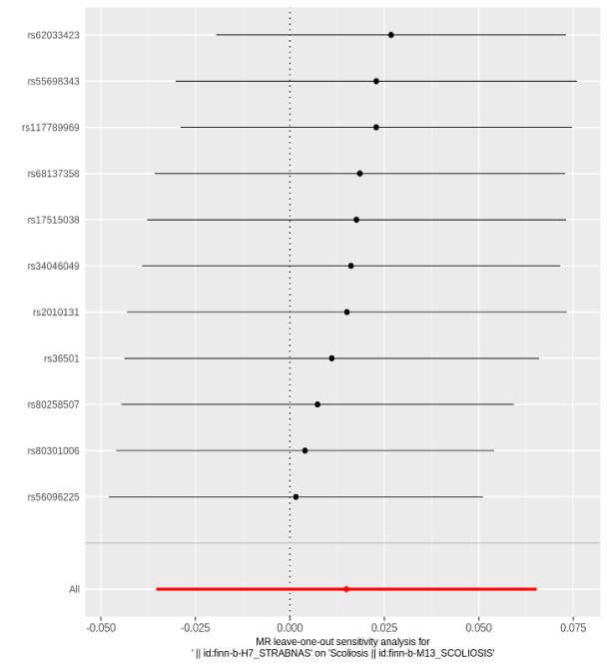**C D**

**Supplementary Figure 4. Results of "Leave-one-out" sensitivity analysis of strabismus subtype**

((A) Sensitivity analysis results of finn_Scoliosis and Ccs (B) Sensitivity analysis results of finn_Scoliosis and Dcs. (C) Sensitivity analysis results of finn_Scoliosis and Os (D) Sensitivity analysis results of finn_Scoliosis and Osus.)

**Supplementary Table 5. Results of Mendelian randomization heterogeneity test**

|  |  |  |  |  |  |
| --- | --- | --- | --- | --- | --- |
| **Outcome** | **exposure** | **method** | **Q** | **Q_df** | ***Q_pval*** |
| ukb_Strabismus | finn_Scoliosis | MR Egger | 13.48 | 12 | *0.335* |
| ukb_Strabismus | finn_Scoliosis | Inverse variance weighted | 13.83 | 13 | *0.386* |
| finn_Strabismus | finn_Scoliosis | MR Egger | 20.84 | 20 | *0.407* |
| finn_Strabismus | finn_Scoliosis s | Inverse variance weighted | 20.85 | 21 | *0.468* |

**A B**

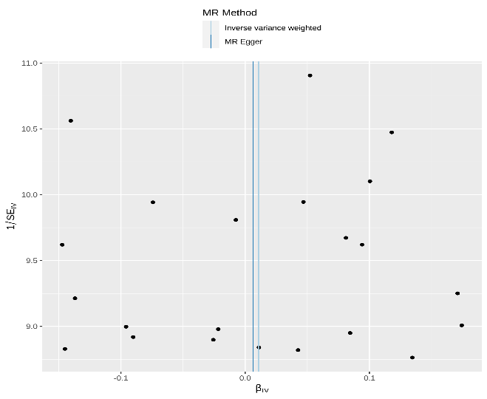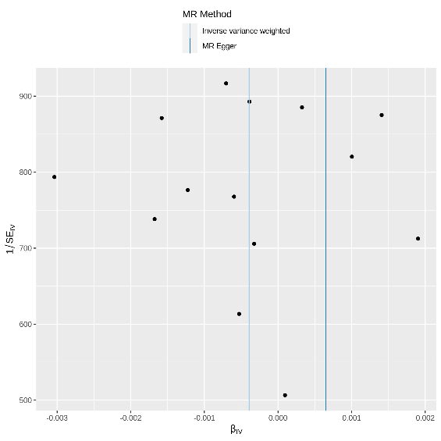

**Supplementary Figure 5. Funnel plot of heterogeneity test results was analyzed by MR Method.**

( (A) Funnel plot of finn_Scoliosis and ukb_Strabismus；(B) Funnel plot of finn_Scoliosis and finn_Strabismus.)

**Supplementary Table 6.** **Directional horizontal pleiotropy test**

|  |  |  |  |  |
| --- | --- | --- | --- | --- |
| **Exposure** | **outcome** | **Egger_intercept** | **SE** | ***P*** |
| finn_Scoliosis | ukb_Strabismus | 0.002 | 0.015 | *0.917* |
| finn_Scoliosis | finn_Strabismus | 0.034 | 0.042 | *0.430* |

**A B**

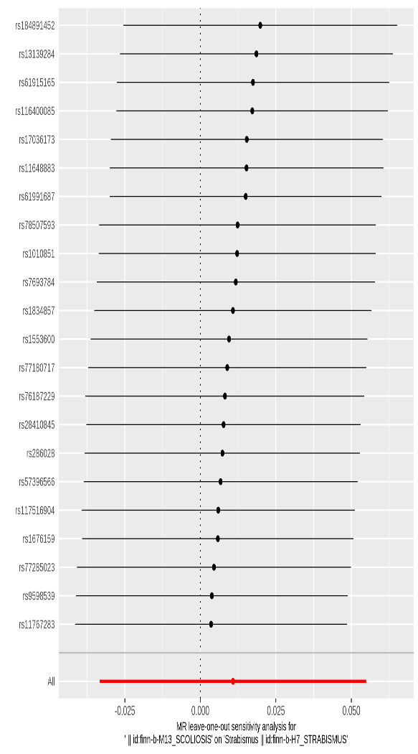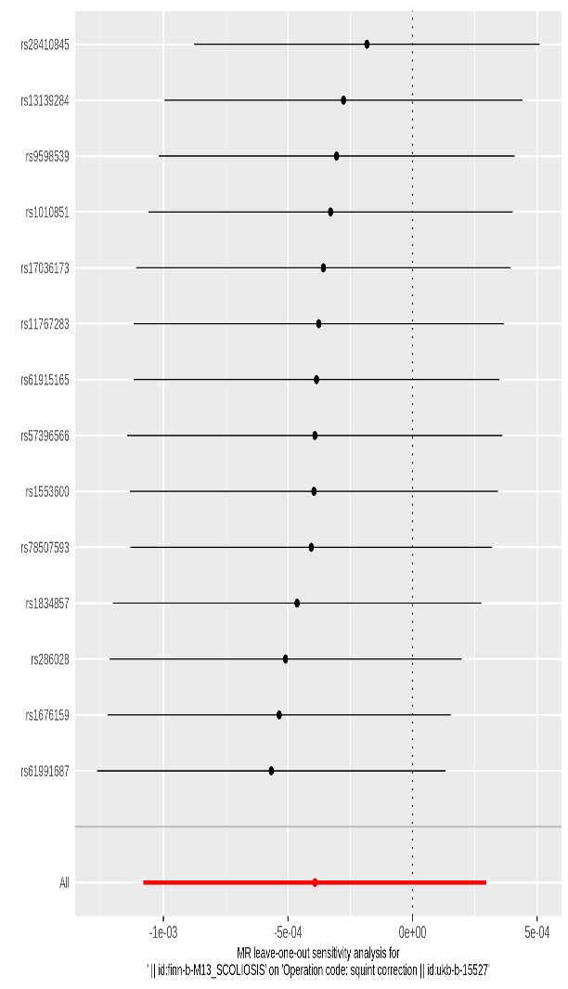

**Supplementary Figure 6.** **Sensitivity analysis results of ‘Leave-one-out’**

( (A) Sensitivity analysis results of finn_Scoliosis and ukb_Strabismus (B) Sensitivity analysis results of finn_Scoliosis and finn_Strabismus.)

**Supplementary Table 7. Results of Mendelian random heterogeneity test for strabismus subsets**

|  |  |  |  |  |  |  |  |
| --- | --- | --- | --- | --- | --- | --- | --- |
| **exposure** | **outcome** | | | **method** | **Q** | **Q_df** | ***Q_pval*** |
| finn_Scoliosis | | Ccs | MR Egger | | 18.52 | 20.00 | *0.553* |
| finn_Scoliosis | | Ccs | Inverse variance weighted | | 18.69 | 21.00 | *0.605* |
| finn_Scoliosis | | Dcs | MR Egger | | 18.04 | 20.00 | *0.585* |
| finn_Scoliosis | | Dcs | Inverse variance weighted | | 18.10 | 21.00 | *0.643* |

**A B**

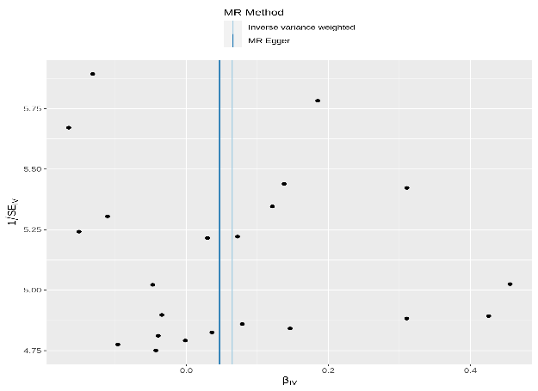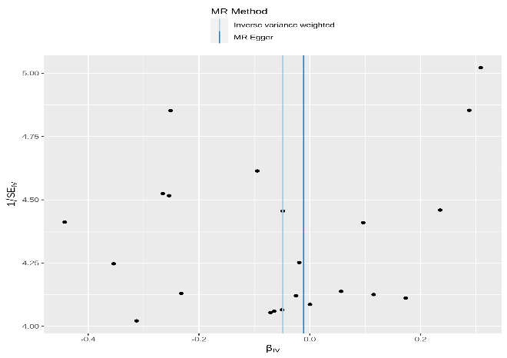

**Supplementary Figure7. Funnel plot of heterogeneity test results was analyzed by MR Method.**

((A) Funnel plot of finn_Scoliosis and Ccs；(B) Funnel plot of finn_Scoliosis and Dcs. )

**Supplementary Table 8.** Directional horizontal pleiotropy test

|  |  |  |  |  |
| --- | --- | --- | --- | --- |
| **exposure** | **outcome** | **Egger_intercept** | **SE** | ***P*** |
| finn_Scoliosis | Ccs | 0.006 | 0.03 | *0.818* |
| finn_Scoliosis | Dcs | -0.013 | 0.03 | *0.682* |

**A B**

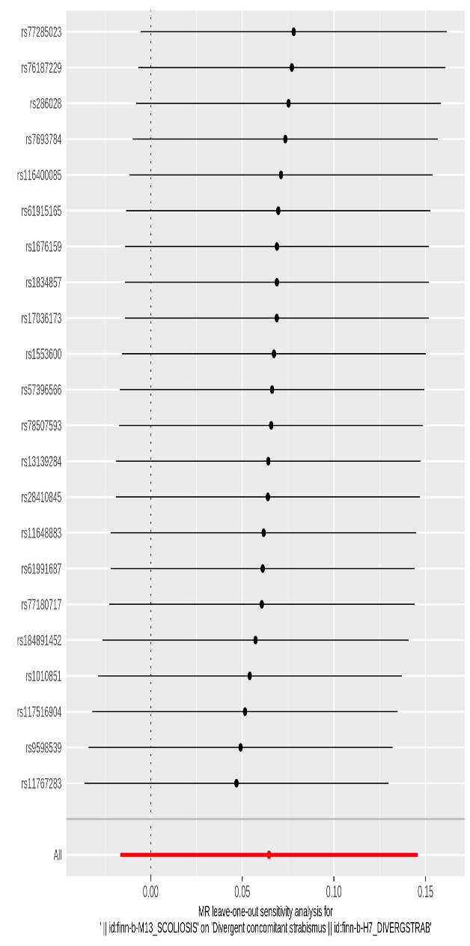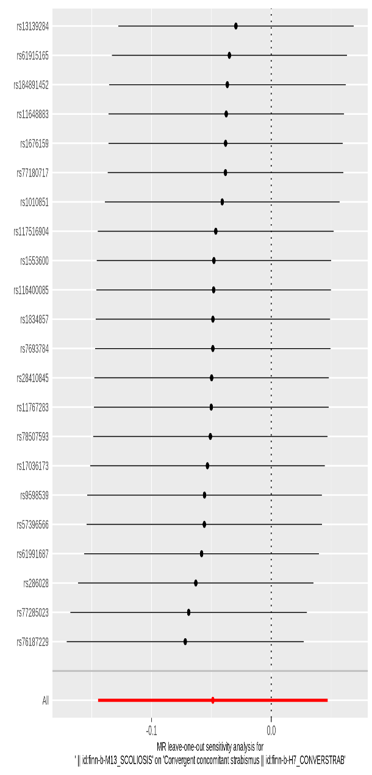

**Supplementary Figure 8.** **Results of "Leave-one-out" sensitivity analysis of strabismus subtype**

**(**(A) Sensitivity analysis results of finn_Scoliosis and Ccs (B) Sensitivity analysis results of finn_Scoliosis and Dcs.)