Pulmonary Contrast- and Non-contrast- Enhanced Computed Tomography Image Registration Based on Multi-resolution B-spline Transformation

Supplementary Figures
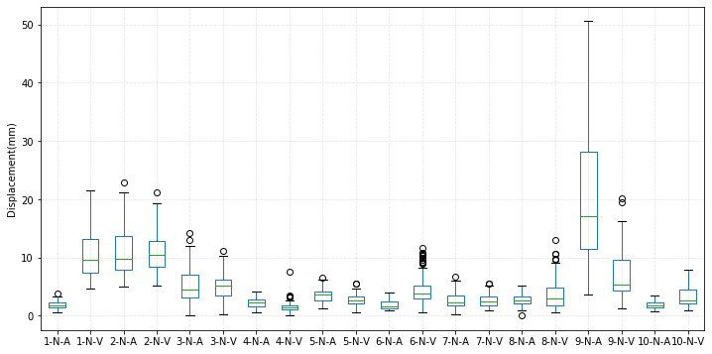
Supplementary Fig. 1 Box diagram of the lung feature point displacements for all 10 cases

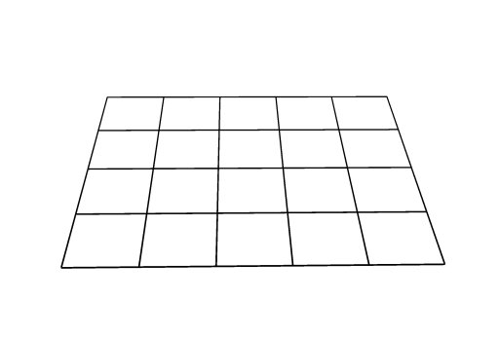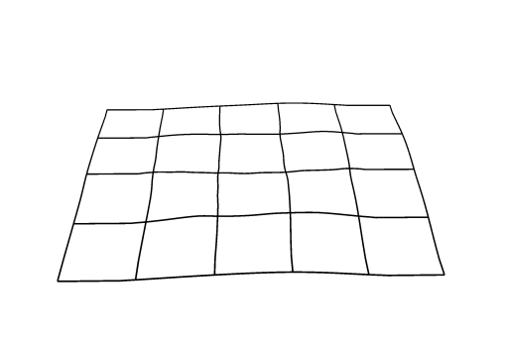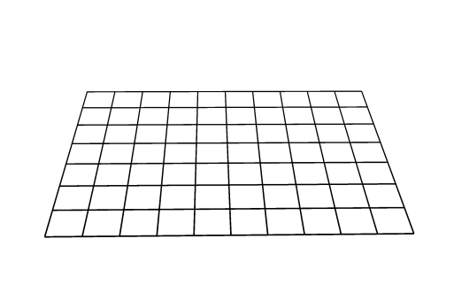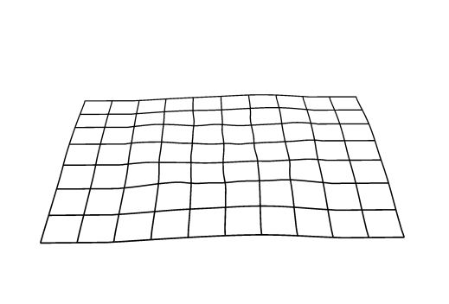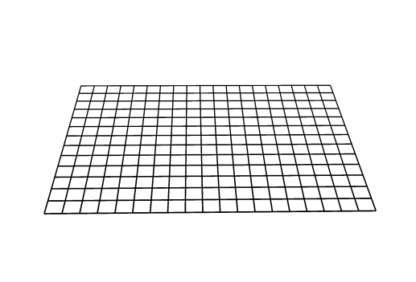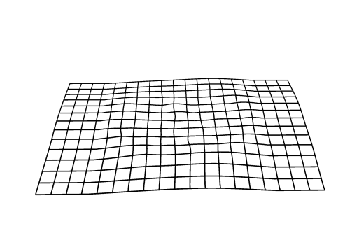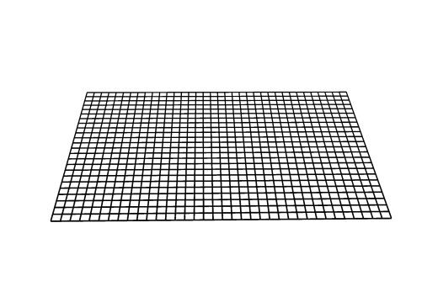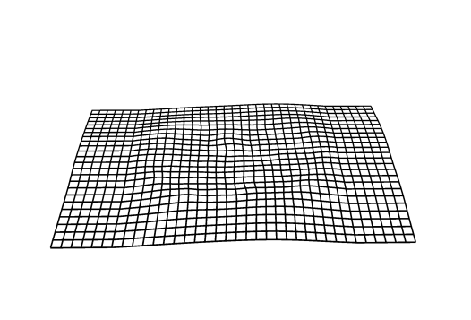
Supplementary Fig. 2 Coarse-to-fine registration for multi-resolution B-spline transformation with resolutions 64, 32, 16, and 8. The first column shows the control grids, while the second column shows the control grids after B-spline transformation.

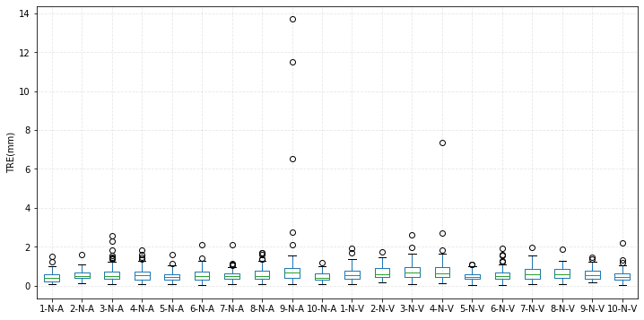
Supplementary Fig. 3 Box diagram of the target registration error (TRE) for each case.

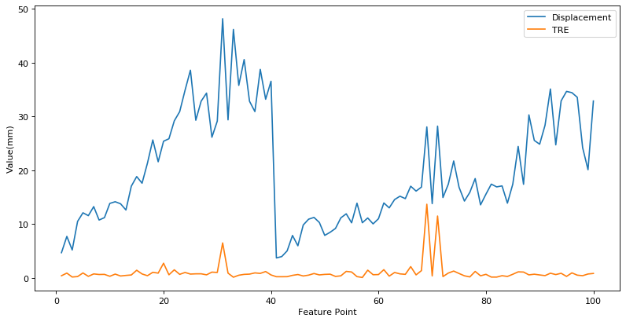
Supplementary Fig.4 Line chart of the displacement and target registration error (TRE) for case 9-N-A.

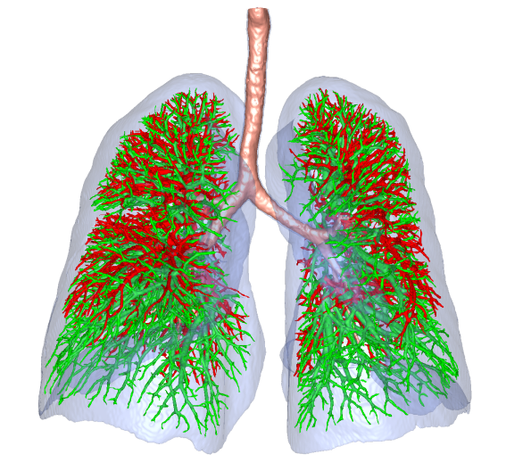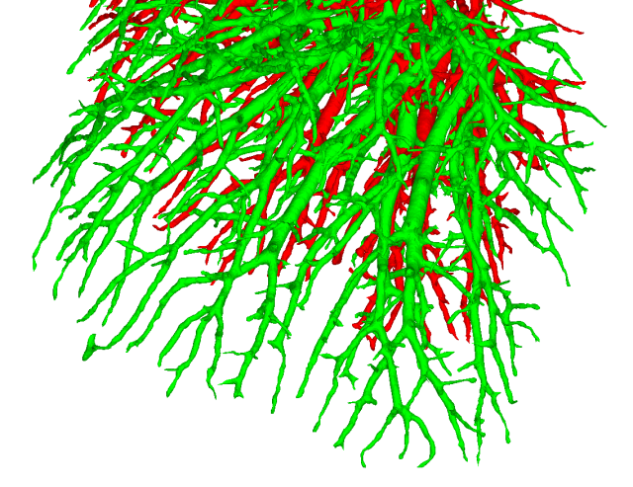
(a)
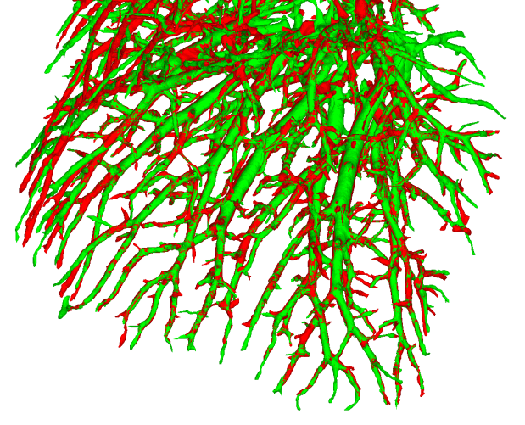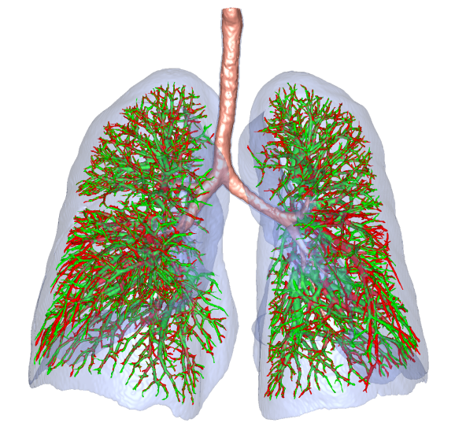
(b)
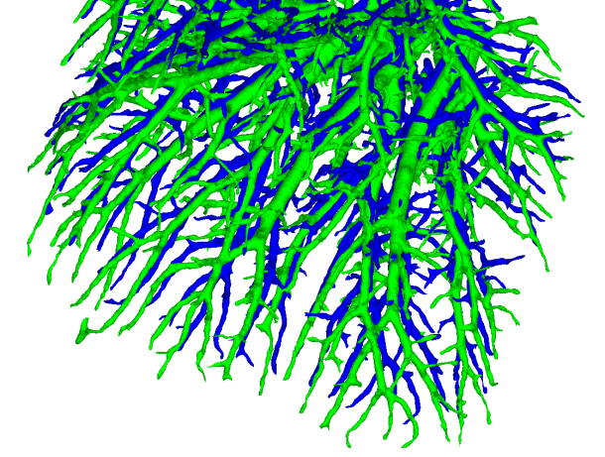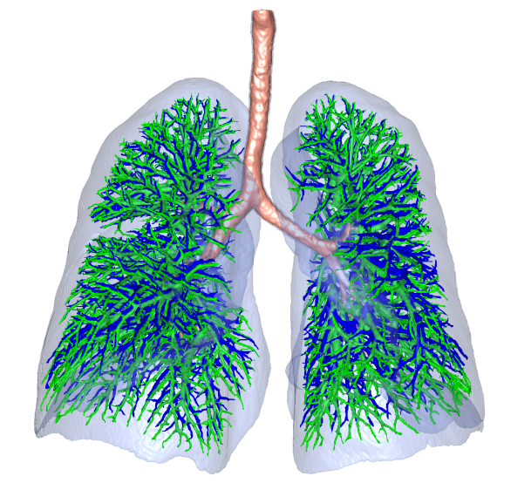
(c)
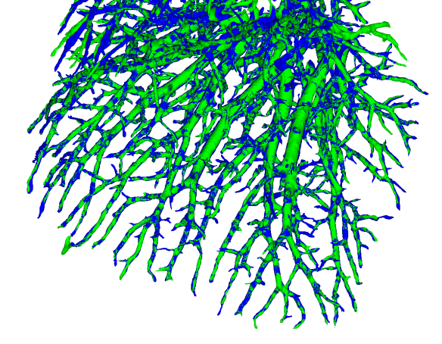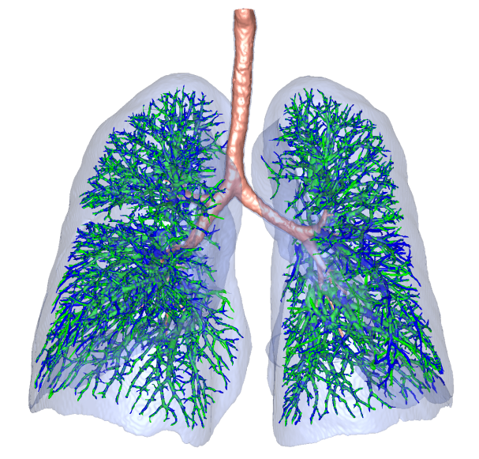
(d)

Supplementary Fig. 5 Three-dimensional lung vessel reconstruction of case 9. (a) The green vessel represents the plain scan (C); the red vessel represents the arterial-phase scan (A) before registration. (b) The green vessel represents the plain scan (C); the blue vessel represents the venous-phase scan (V) before registration. (c) The green vessel represents the plain scan (C); the red vessel represents the arterial-phase scan (A) after registration. (d) The green vessel represents the plain scan (C); the blue vessel represents the venous-phase scan (V) after registration.

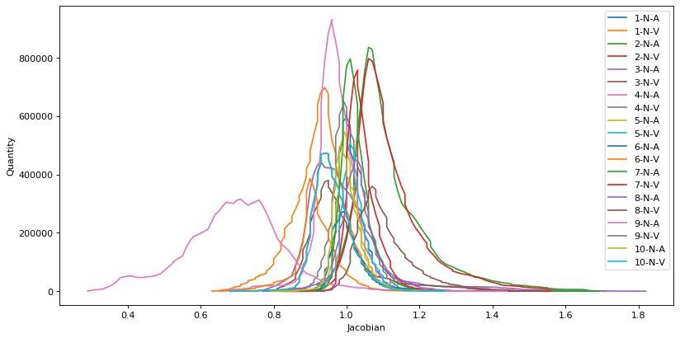
Supplementary Fig. 6 Line chart of the Jacobian determinants for each case

Supplementary Tables

Supplementary Table 1. Comparison results (mm) of sampling strategies.
Sampling strategy |  | Before reg | Without mask | With mask
Case 1 | N–A | 1.85±0.60 | 0.51±0.26 | 0.43±0.27
 | N–V | 10.29±3.75 | 0.85±0.91 | 0.58±0.34
Case 2 | N–A | 10.87±3.99 | 1.05±0.98 | 0.53±0.25
 | N–V | 10.77±3.10 | 0.99±0.85 | 0.66±0.34
Case 3 | N–A | 5.29±3.04 | 1.24±1.47 | 0.62±0.43
 | N–V | 5.08±2.46 | 1.15±1.08 | 0.75±0.41
Case 4 | N–A | 2.30±0.82 | 0.64±0.39 | 0.57±0.35
 | N–V | 1.54±0.89 | 0.82±0.77 | 0.80±0.78
Case 5 | N–A | 3.69±1.16 | 0.67±0.40 | 0.48±0.25
 | N–V | 2.63±0.96 | 0.61±0.35 | 0.47±0.22
Case 6 | N–A | 1.96±0.81 | 0.59±0.30 | 0.54±0.32
 | N–V | 4.48±2.50 | 0.94±0.86 | 0.55±0.32
Case 7 | N–A | 2.73±1.32 | 0.69±0.51 | 0.52±0.27
 | N–V | 2.59±1.10 | 0.89±0.81 | 0.64±0.36
Case 8 | N–A | 2.69±0.97 | 0.64±0.35 | 0.59±0.33
 | N–V | 3.75±2.80 | 1.01±0.91 | 0.62±0.32
Case 9 | N–A | 19.79±10.36 | 8.86±7.28 | 1.00±1.82
 | N–V | 6.97±3.96 | 1.00±0.94 | 0.58±0.27
Case 10 | N–A | 1.85±0.52 | 0.50±0.21 | 0.46±0.24
 | N–V | 3.17±1.61 | 0.69±0.51 | 0.49±0.31
All 10 cases |  | 5.52±5.46 | 1.22±2.51 | 0.59±0.55

Supplementary Table 2. Comparison results (mm) of final control point spacing in multi-resolution strategies.
Final control point spacing |  | Before reg | 64 | 32 | 16 | 8
Case 1 | N–A | 1.85±0.60 | 0.49±0.26 | 0.46±0.27 | 0.43±0.27 | 0.44±0.26
 | N–V | 10.29±3.75 | 0.92±0.53 | 0.69±0.41 | 0.58±0.34 | 0.58±0.35
Case 2 | N–A | 10.87±3.99 | 1.12±0.73 | 0.68±0.39 | 0.53±0.25 | 0.50±0.35
 | N–V | 10.77±3.10 | 1.21±0.67 | 0.79±0.37 | 0.66±0.34 | 0.64±0.31
Case 3 | N–A | 5.29±3.04 | 1.06±0.77 | 0.68±0.48 | 0.62±0.43 | 0.63±0.43
 | N–V | 5.08±2.46 | 1.09±0.76 | 0.82±0.45 | 0.75±0.41 | 0.74±0.44
Case 4 | N–A | 2.30±0.82 | 0.70±0.36 | 0.63±0.35 | 0.57±0.35 | 0.57±0.35
 | N–V | 1.54±0.89 | 0.96±0.75 | 0.82±0.77 | 0.80±0.78 | 0.80±0.79
Case 5 | N–A | 3.69±1.16 | 0.62±0.29 | 0.52±0.26 | 0.48±0.25 | 0.46±0.27
 | N–V | 2.63±0.96 | 0.62±0.28 | 0.50±0.22 | 0.47±0.22 | 0.46±0.23
Case 6 | N–A | 1.96±0.81 | 0.64±0.33 | 0.56±0.33 | 0.54±0.32 | 0.51±0.36
 | N–V | 4.48±2.50 | 0.72±0.37 | 0.62±0.30 | 0.55±0.32 | 0.50±0.30
Case 7 | N–A | 2.73±1.32 | 0.73±0.35 | 0.62±0.30 | 0.52±0.27 | 0.49±0.30
 | N–V | 2.59±1.10 | 0.74±0.34 | 0.68±0.33 | 0.64±0.36 | 0.62±0.39
Case 8 | N–A | 2.69±0.97 | 0.74±0.35 | 0.65±0.35 | 0.59±0.33 | 0.57±0.35
 | N–V | 3.75±2.80 | 0.80±0.49 | 0.69±0.40 | 0.62±0.32 | 0.57±0.30
Case 9 | N–A | 19.79±10.36 | 2.27±2.40 | 1.41±1.79 | 1.00±1.82 | 1.09±2.13
 | N–V | 6.97±3.96 | 1.00±0.79 | 0.71±0.51 | 0.58±0.27 | 0.60±0.28
Case 10 | N–A | 1.85±0.52 | 0.53±0.25 | 0.50±0.23 | 0.46±0.24 | 0.47±0.25
 | N–V | 3.17±1.61 | 0.67±0.40 | 0.55±0.32 | 0.49±0.31 | 0.49±0.28
All 10 cases |  | 5.52±5.46 | 0.88±0.82 | 0.68±0.59 | 0.59±0.55 | 0.59±0.61

Supplementary Table 3. Comparison results (mm) of final control point resolution in multi-resolution strategies.
Number Of Resolutions |  | Before reg | 3 | 4 | 5 | 6
Case 1 | N–A | 1.85±0.60 | 0.43±0.26 | 0.44±0.26 | 0.43±0.26 | 0.43±0.27
 | N–V | 10.29±3.75 | 0.58±0.33 | 0.59±0.34 | 0.59±0.34 | 0.58±0.34
Case 2 | N–A | 10.87±3.99 | 0.54±0.26 | 0.53±0.25 | 0.53±0.25 | 0.53±0.25
 | N–V | 10.77±3.10 | 0.66±0.34 | 0.65±0.34 | 0.65±0.34 | 0.66±0.34
Case 3 | N–A | 5.29±3.04 | 0.62±0.42 | 0.63±0.43 | 0.61±0.43 | 0.62±0.43
 | N–V | 5.08±2.46 | 0.74±0.41 | 0.74±0.41 | 0.75±0.41 | 0.75±0.41
Case 4 | N–A | 2.30±0.82 | 0.57±0.34 | 0.57±0.34 | 0.55±0.34 | 0.57±0.35
 | N–V | 1.54±0.89 | 0.80±0.78 | 0.79±0.78 | 0.79±0.78 | 0.80±0.78
Case 5 | N–A | 3.69±1.16 | 0.47±0.25 | 0.47±0.25 | 0.47±0.25 | 0.48±0.25
 | N–V | 2.63±0.96 | 0.48±0.22 | 0.47±0.22 | 0.47±0.22 | 0.47±0.22
Case 6 | N–A | 1.96±0.81 | 0.54±0.33 | 0.53±0.33 | 0.54±0.33 | 0.54±0.32
 | N–V | 4.48±2.50 | 0.55±0.32 | 0.55±0.32 | 0.56±0.32 | 0.55±0.32
Case 7 | N–A | 2.73±1.32 | 0.53±0.26 | 0.52±0.26 | 0.52±0.26 | 0.52±0.27
 | N–V | 2.59±1.10 | 0.65±0.37 | 0.64±0.36 | 0.64±0.36 | 0.64±0.36
Case 8 | N–A | 2.69±0.97 | 0.59±0.33 | 0.59±0.34 | 0.59±0.34 | 0.59±0.33
 | N–V | 3.75±2.80 | 0.62±0.32 | 0.63±0.32 | 0.62±0.31 | 0.62±0.32
Case 9 | N–A | 19.79±10.36 | 4.95±8.58 | 0.96±1.60 | 0.92±1.54 | 1.00±1.82
 | N–V | 6.97±3.96 | 0.58±0.26 | 0.58±0.26 | 0.59±0.29 | 0.58±0.27
Case 10 | N–A | 1.85±0.52 | 0.46±0.24 | 0.46±0.24 | 0.46±0.24 | 0.46±0.24
 | N–V | 3.17±1.61 | 0.49±0.32 | 0.48±0.29 | 0.49±0.31 | 0.49±0.31

Supplementary Table 4. Comparison results of similarity measures.
Histogram bins |  | Before reg | 8 | 16 | 32 | 64
Case 1 | N–A | 1.85±0.60 | 0.51±0.35 | 0.46±0.29 | 0.44±0.26 | 0.45±0.24
 | N–V | 10.29±3.75 | 0.74±0.65 | 0.67±0.63 | 0.59±0.34 | 0.57±0.33
Case 2 | N–A | 10.87±3.99 | 2.80±5.34 | 0.82±1.03 | 0.53±0.25 | 0.51±0.23
 | N–V | 10.77±3.10 | 2.85±5.35 | 1.40±2.76 | 0.65±0.34 | 0.63±0.32
Case 3 | N–A | 5.29±3.04 | 1.62±2.37 | 1.00±1.22 | 0.63±0.43 | 0.59±0.41
 | N–V | 5.08±2.46 | 1.59±2.03 | 0.97±0.86 | 0.74±0.41 | 0.73±0.39
Case 4 | N–A | 2.30±0.82 | 0.68±0.39 | 0.61±0.36 | 0.57±0.34 | 0.56±0.33
 | N–V | 1.54±0.89 | 0.89±0.80 | 0.83±0.79 | 0.79±0.78 | 0.78±0.78
Case 5 | N–A | 3.69±1.16 | 0.68±0.75 | 0.47±0.27 | 0.47±0.25 | 0.48±0.25
 | N–V | 2.63±0.96 | 0.83±1.01 | 0.50±0.27 | 0.47±0.22 | 0.47±0.20
Case 6 | N–A | 1.96±0.81 | 0.64±0.42 | 0.54±0.34 | 0.53±0.33 | 0.55±0.31
 | N–V | 4.48±2.50 | 0.65±0.38 | 0.59±0.35 | 0.55±0.32 | 0.55±0.31
Case 7 | N–A | 2.73±1.32 | 0.62±0.34 | 0.54±0.29 | 0.52±0.26 | 0.52±0.25
 | N–V | 2.59±1.10 | 0.74±0.42 | 0.66±0.39 | 0.64±0.36 | 0.63±0.35
Case 8 | N–A | 2.69±0.97 | 0.86±0.76 | 0.63±0.38 | 0.59±0.34 | 0.58±0.30
 | N–V | 3.75±2.80 | 1.17±1.38 | 0.73±0.43 | 0.63±0.32 | 0.61±0.31
Case 9 | N–A | 19.79±10.36 | 1.46±2.29 | 1.30±2.14 | 0.96±1.60 | 4.22±7.85
 | N–V | 6.97±3.96 | 0.70±0.38 | 0.64±0.35 | 0.58±0.26 | 0.57±0.24
Case 10 | N–A | 1.85±0.52 | 0.59±0.33 | 0.49±0.28 | 0.46±0.24 | 0.46±0.22
 | N–V | 3.17±1.61 | 0.58±0.35 | 0.52±0.32 | 0.48±0.29 | 0.48±0.28
All 10 cases |  | 5.52±5.46 | 1.06±2.08 | 0.72±0.98 | 0.59±0.51 | 0.75±1.95

